Explorer Building Program (Approximately £7.50 per box)

Advanced Wooden Design

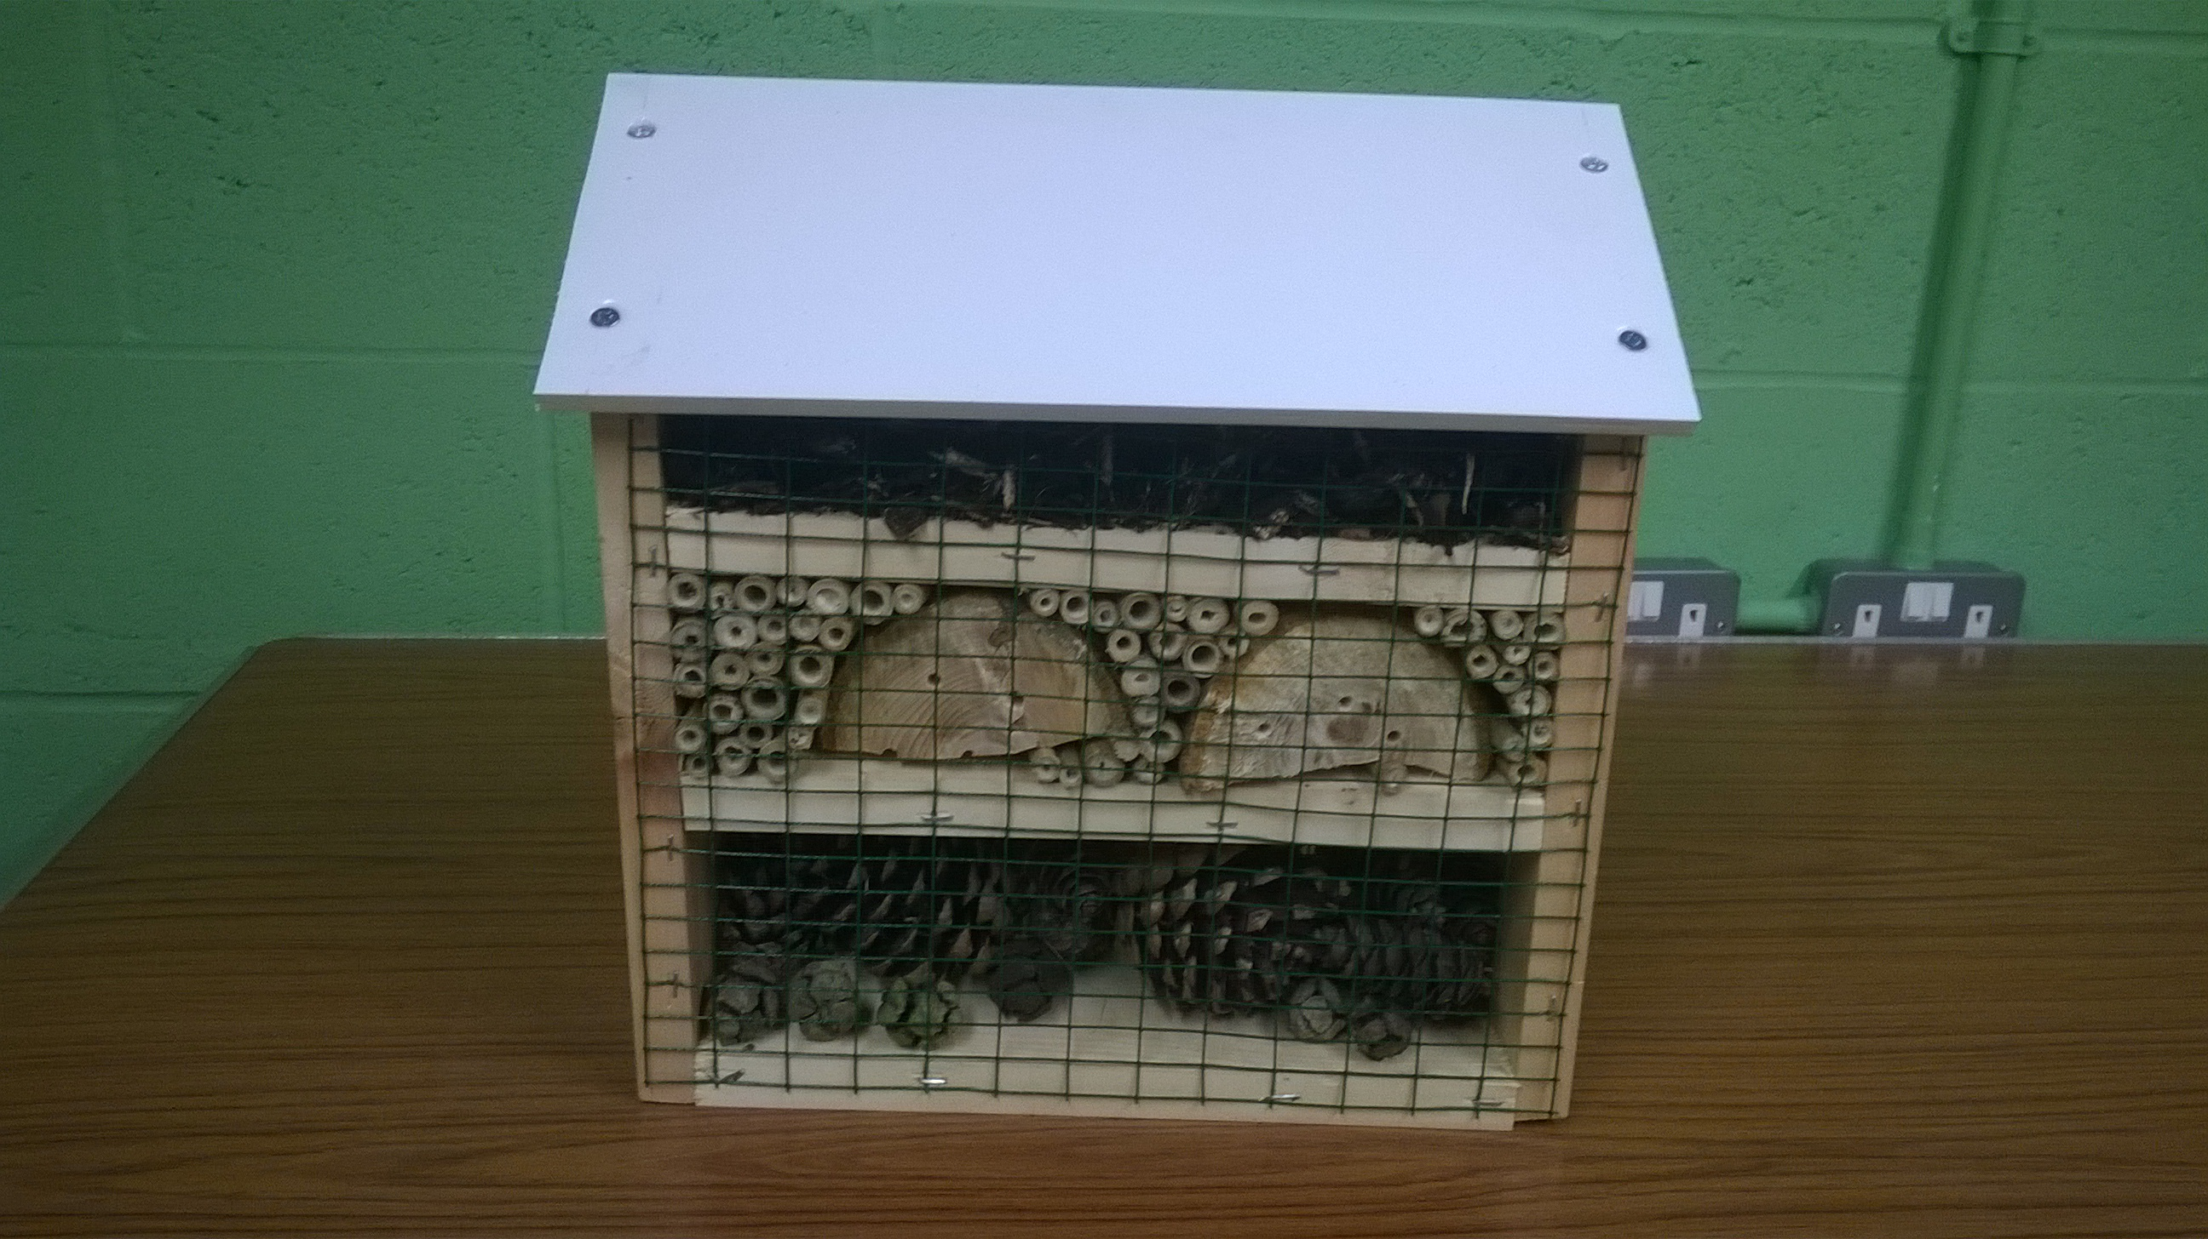

Items needed (per box):
- 1x : 170x9x2.5cm wooden plank
- 1x : 36x15x0.9cm plastic board
- 1x : 70x33cm wire mesh
- 1x : 9cm wooden log (10 -14cm diameter)
- Selection of pine cones
- Selection of bamboo canes
- Bark chippings
- 16x : 1¼” 4mm screws
- Staples
- Masking tape

Equipment needed:
- Several Measuring tapes
- Several Steel rulers
- Pencils
- Pens
- Set square
- Several timber saws
- Wood saw
- Axe (with chopping surface)
- 2x drills
- Selection of drill bits
- Wire cutters
- Screwdriver
- Staple gun
- Hacksaw
- Hammer
- 2 Workbenches

Instructions:
Preparation:

- Measure and cut a 9cm section off the log using the wood saw, make sure the log is held securely in the work bench whilst sawing.
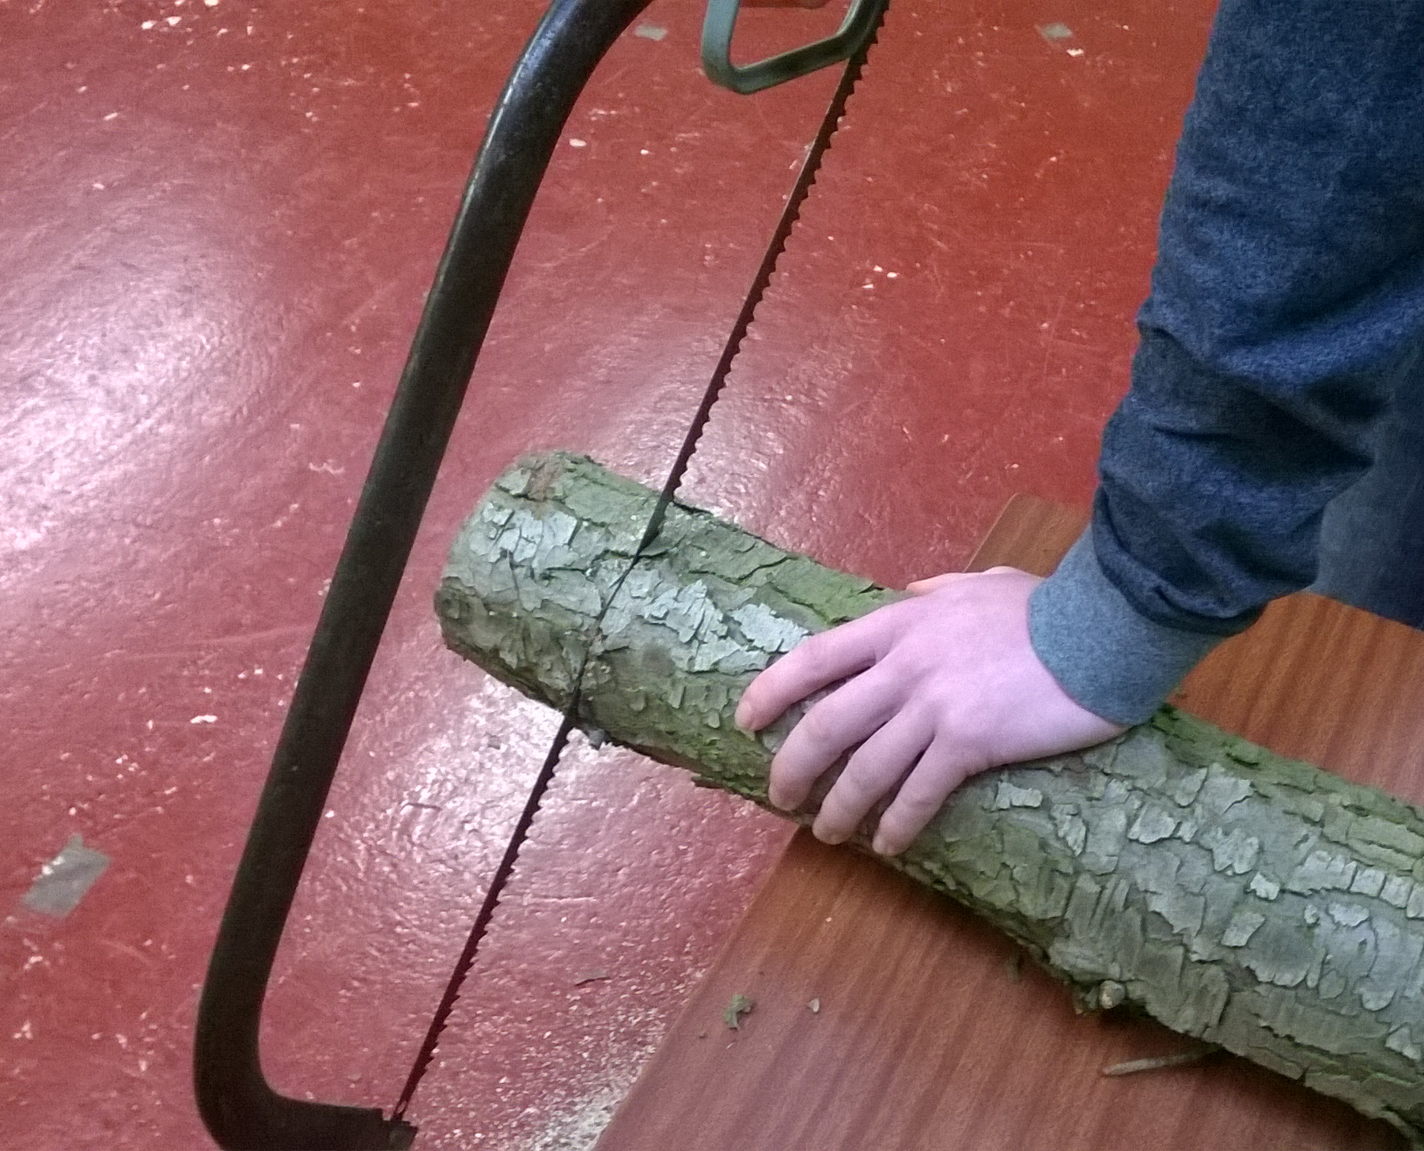
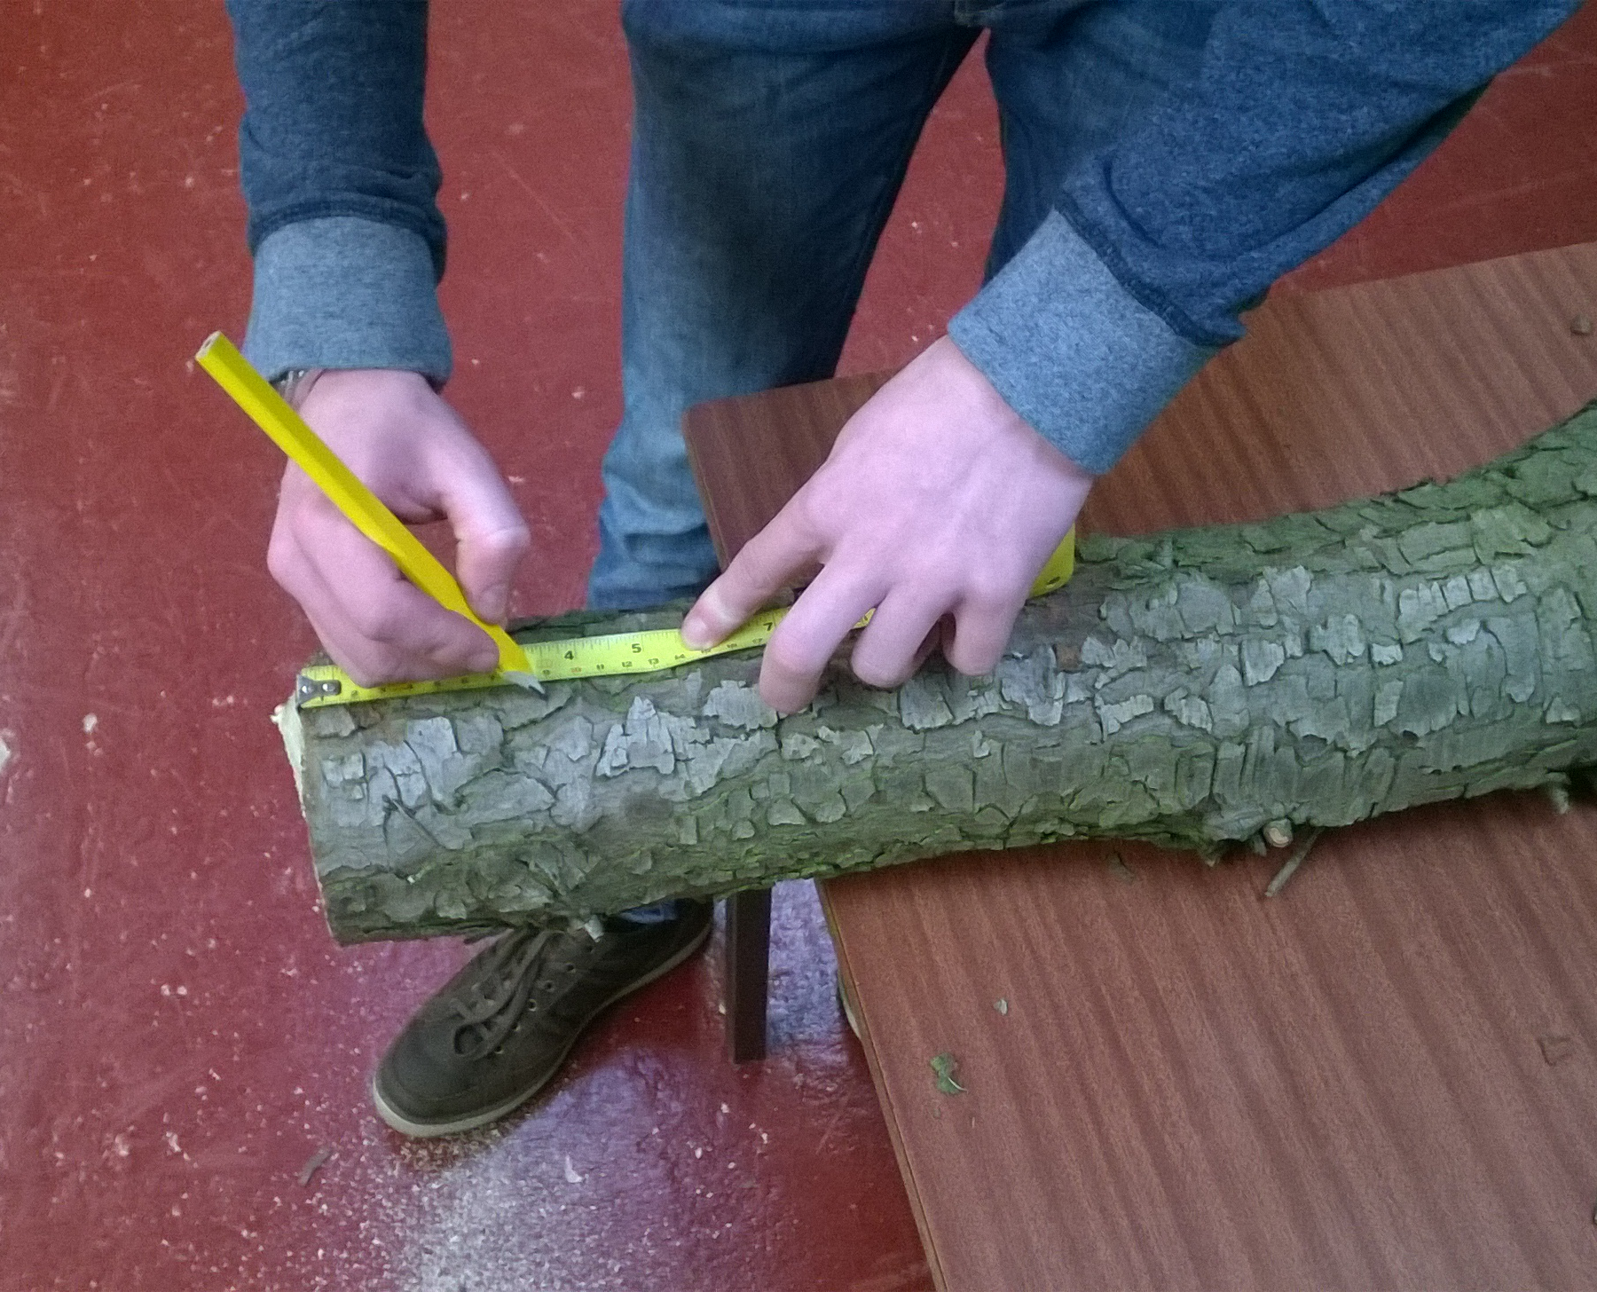

- Secure the log securely in the workbench and drill a selection of holes in either end.

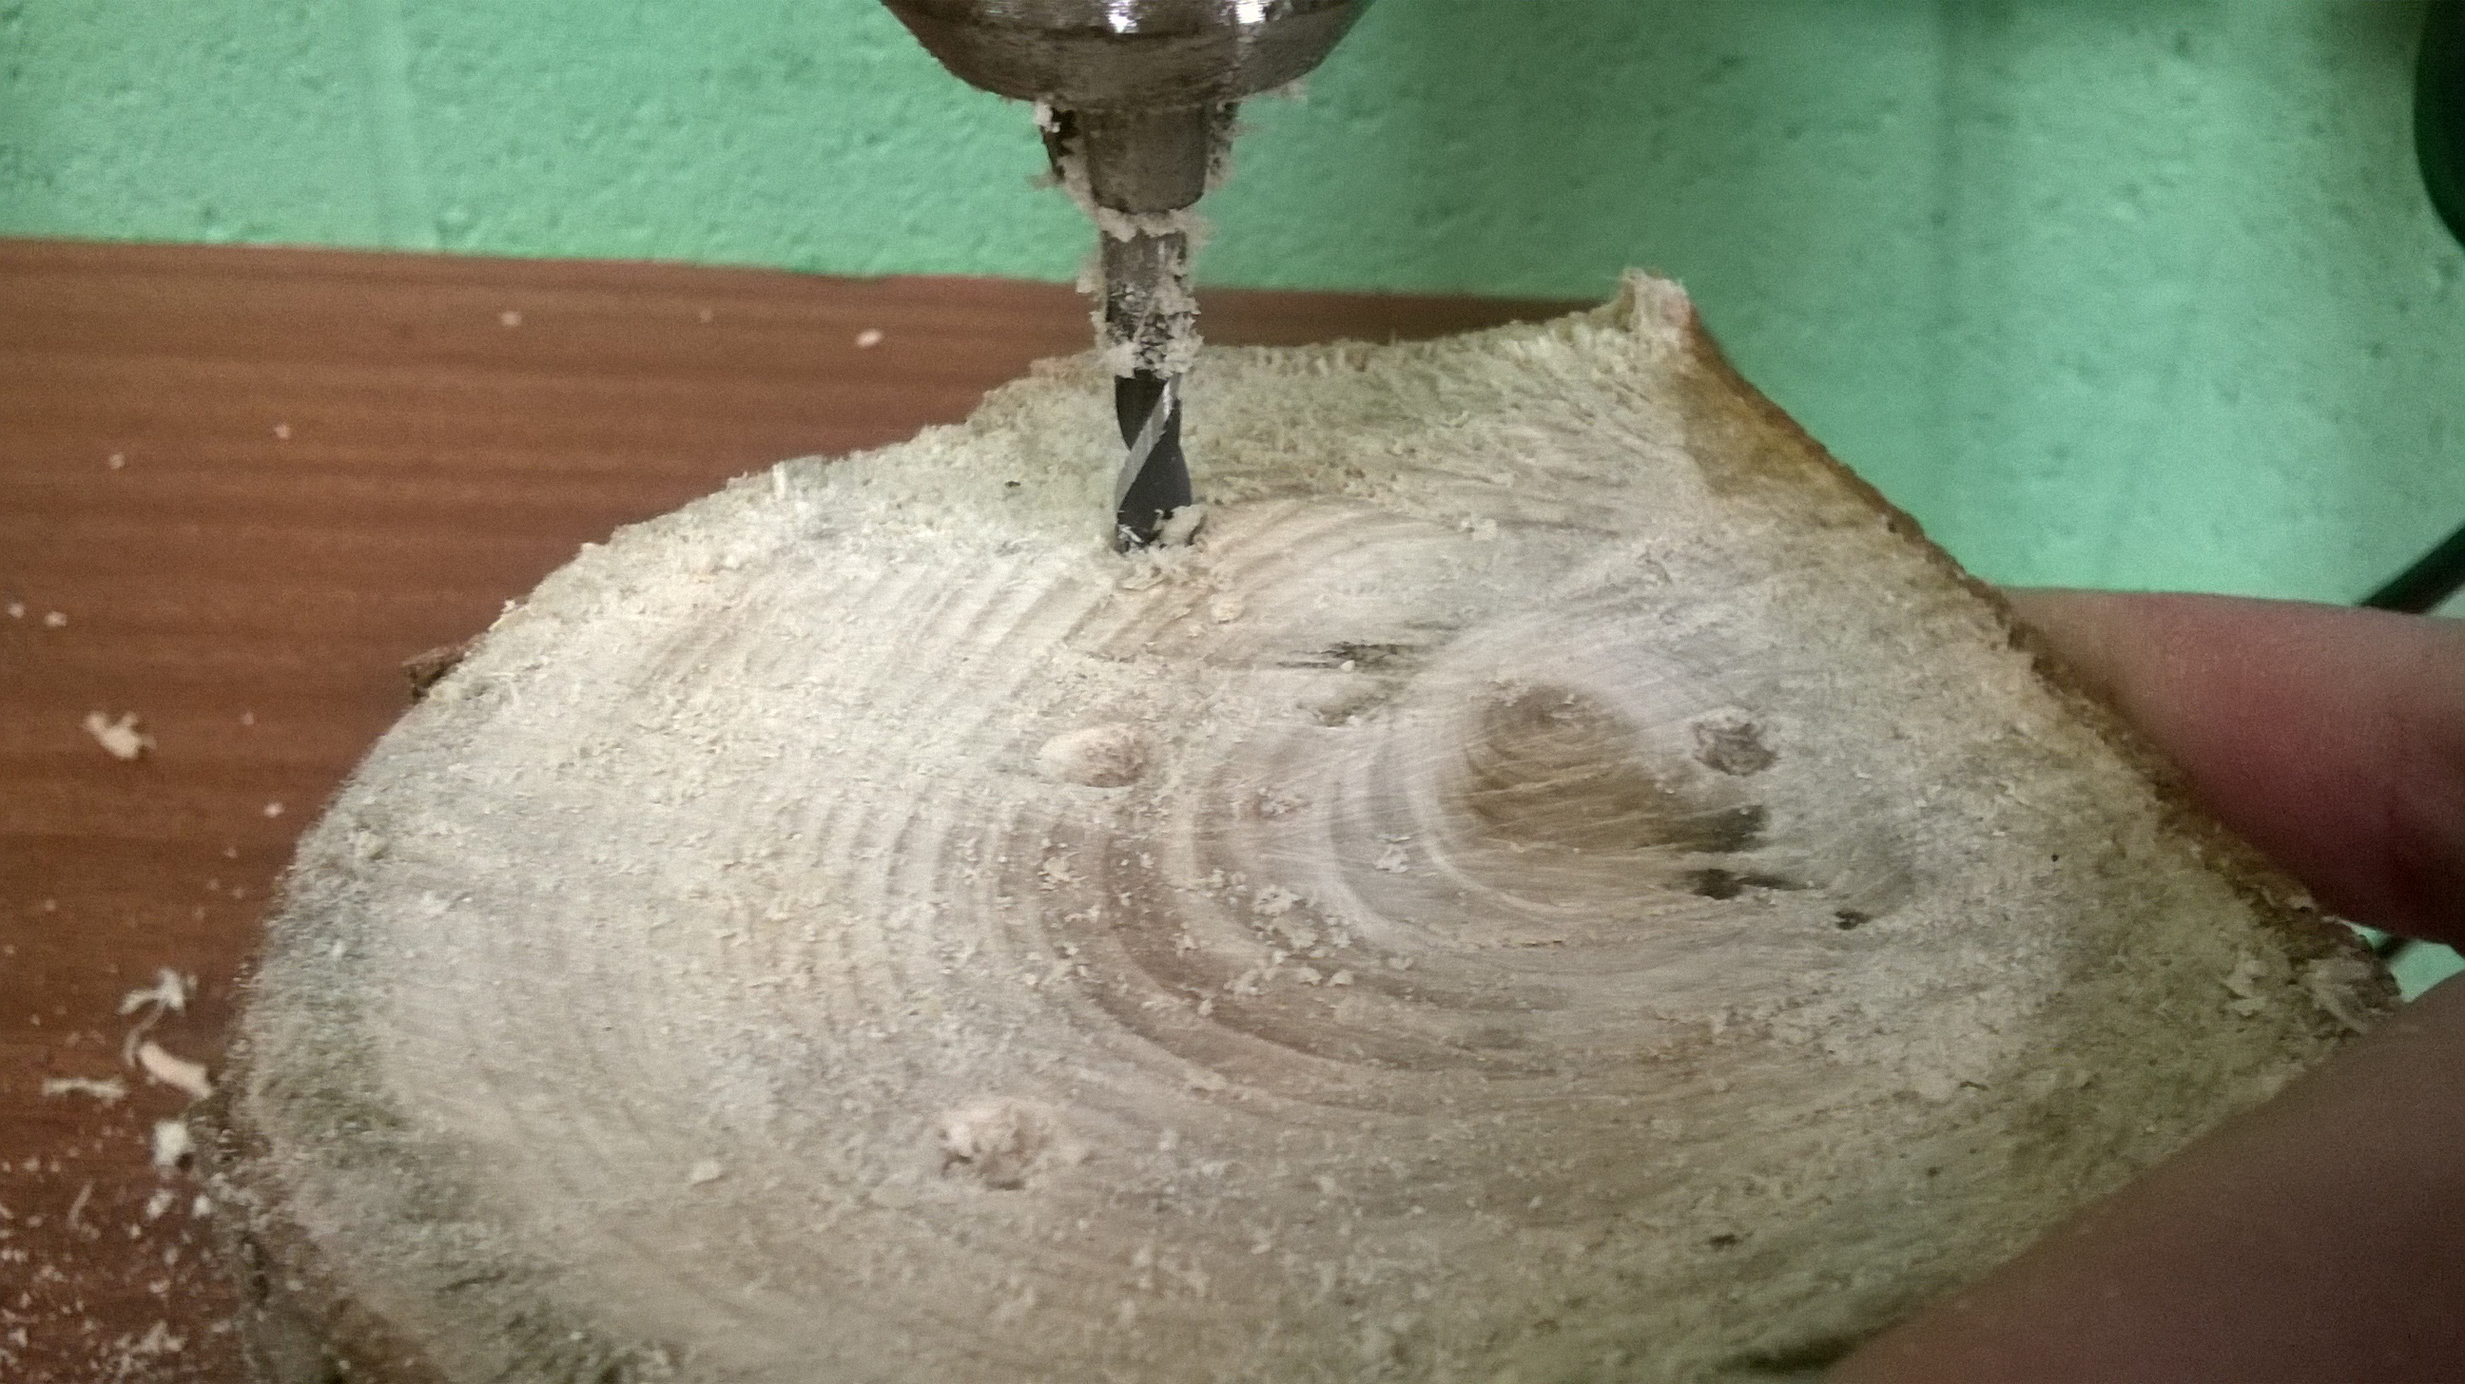

- Split the log in half lengthways with the axe. (this will be in a separate area please follow instructions of leader in charge of axe work)
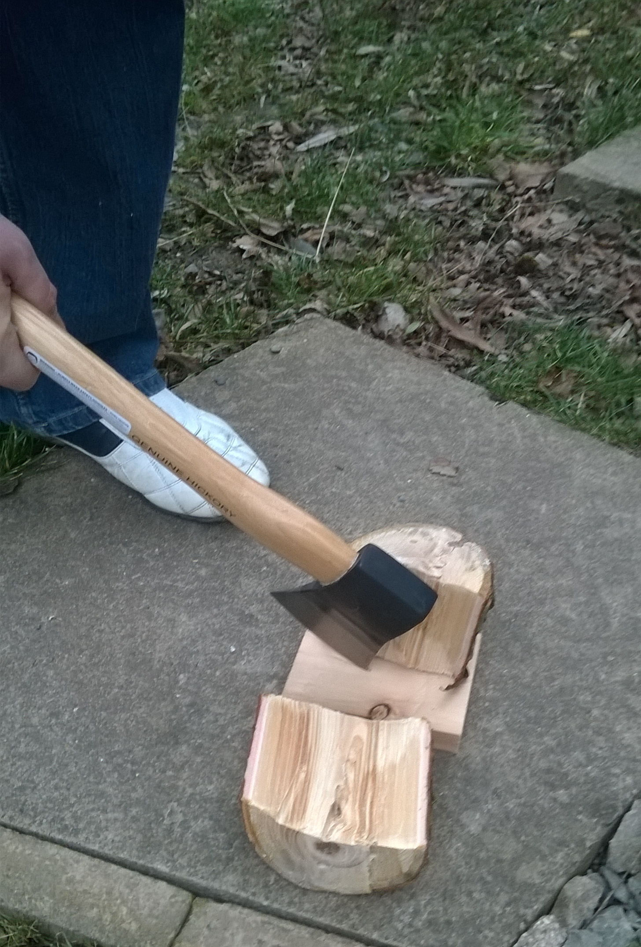
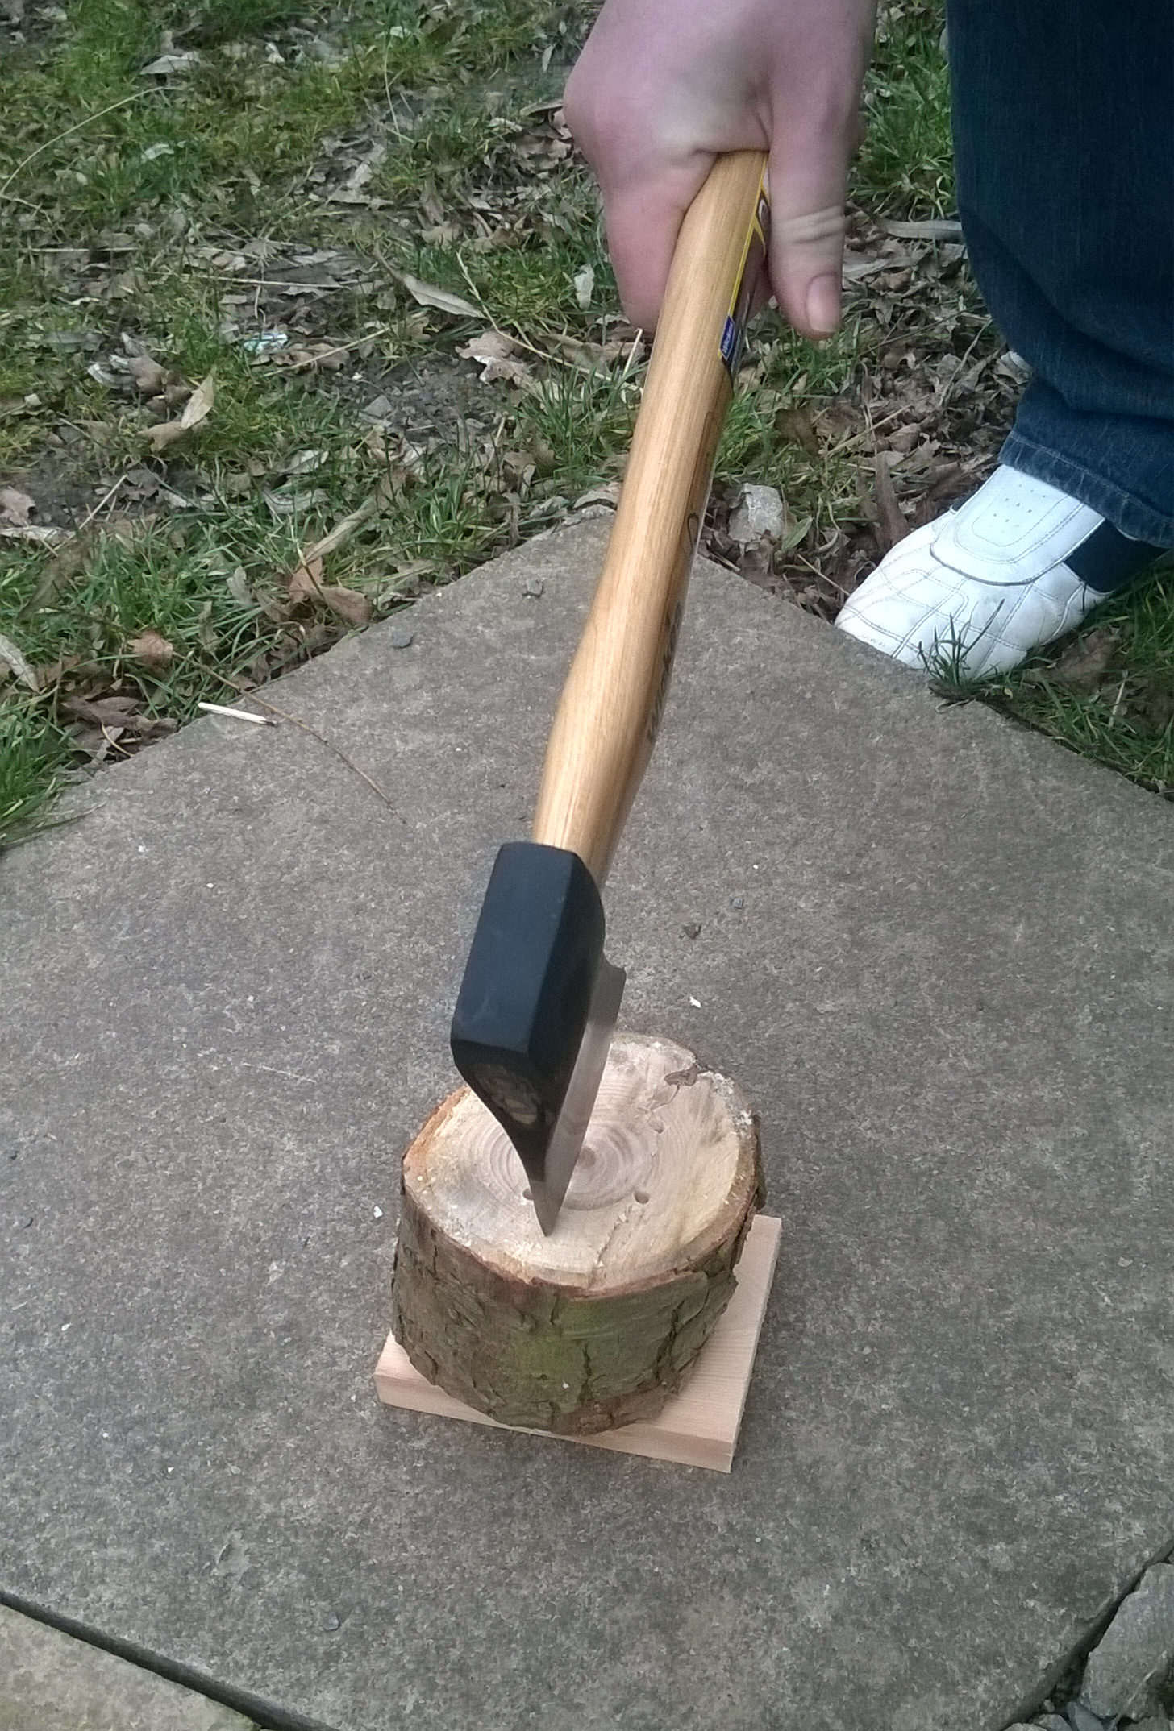

- Measure and cut two pieces of wire mesh one 27x33cm and the other 35x33cm using the wire cutters.

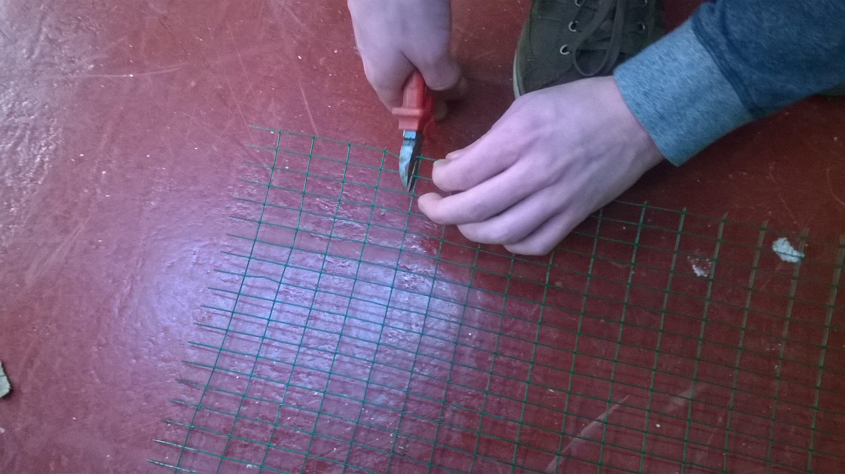
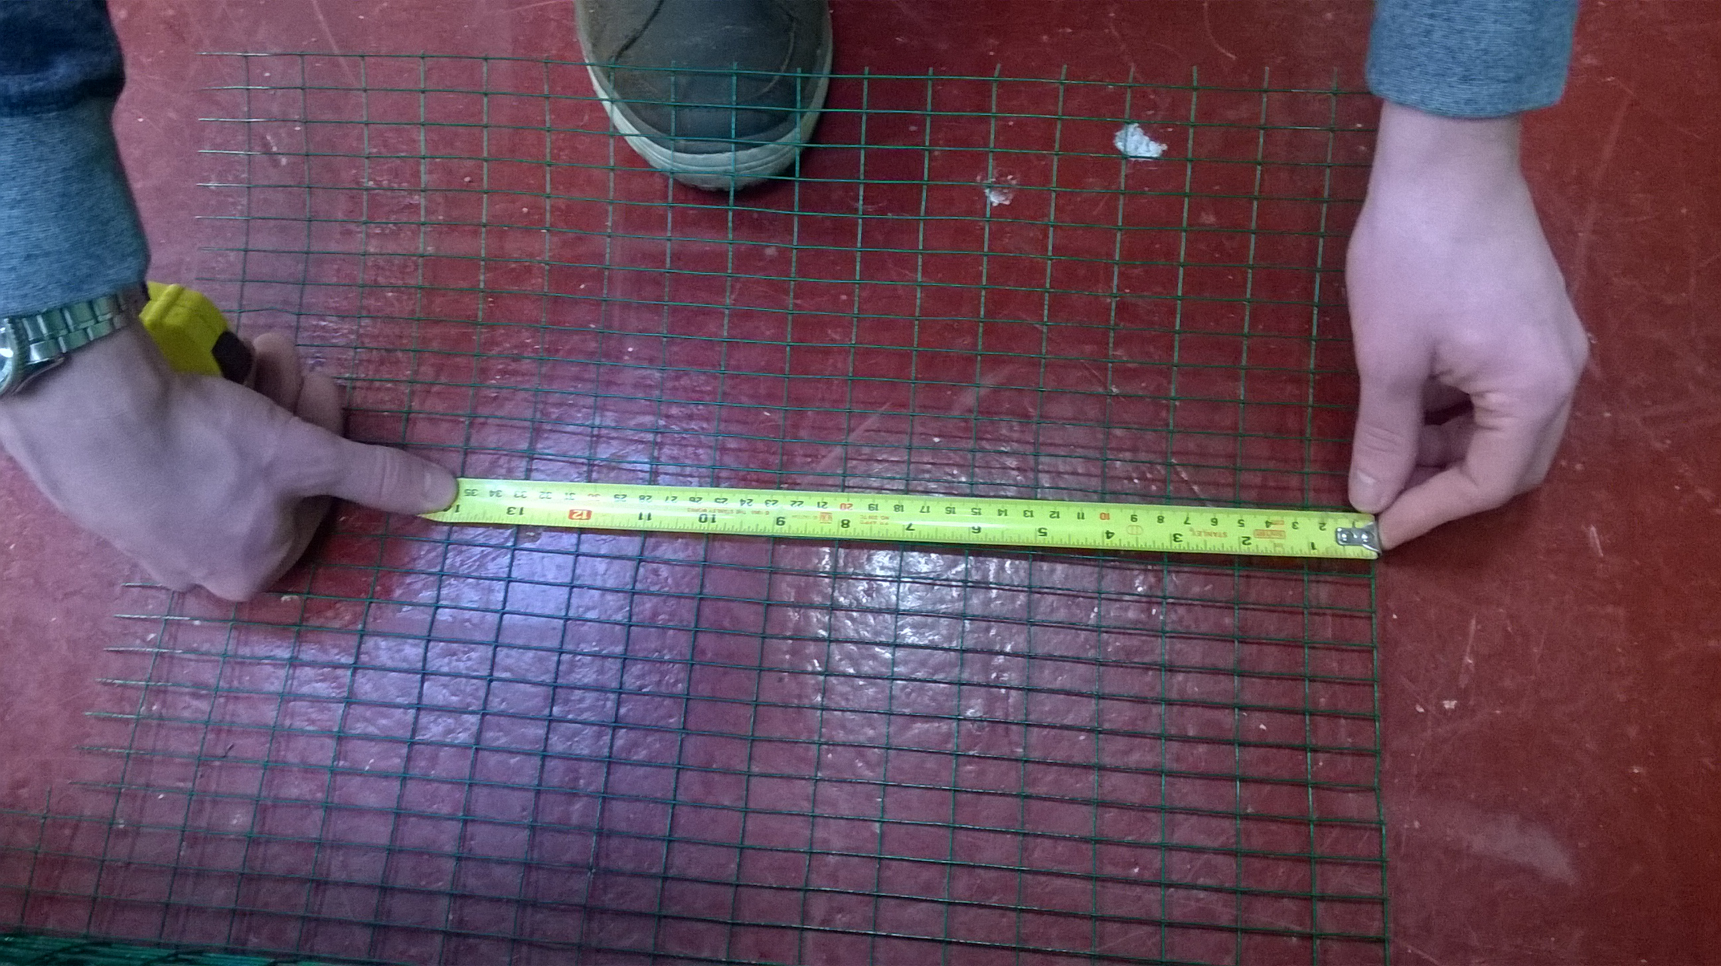

- Measure, mark (using the pen and set square) and cut a 36cm piece plastic board using the hacksaw, make sure not to remove the plastic film covering it.
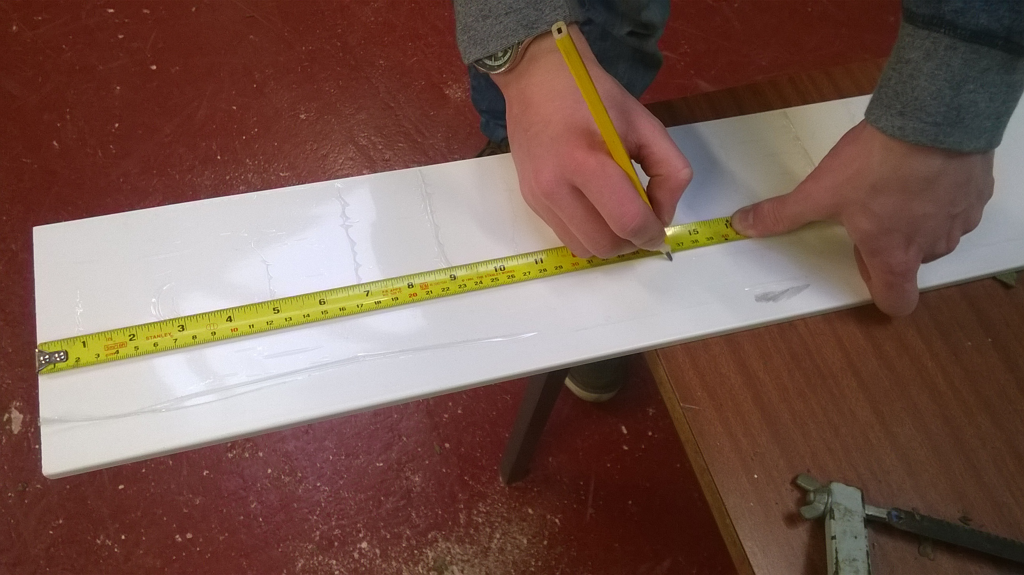
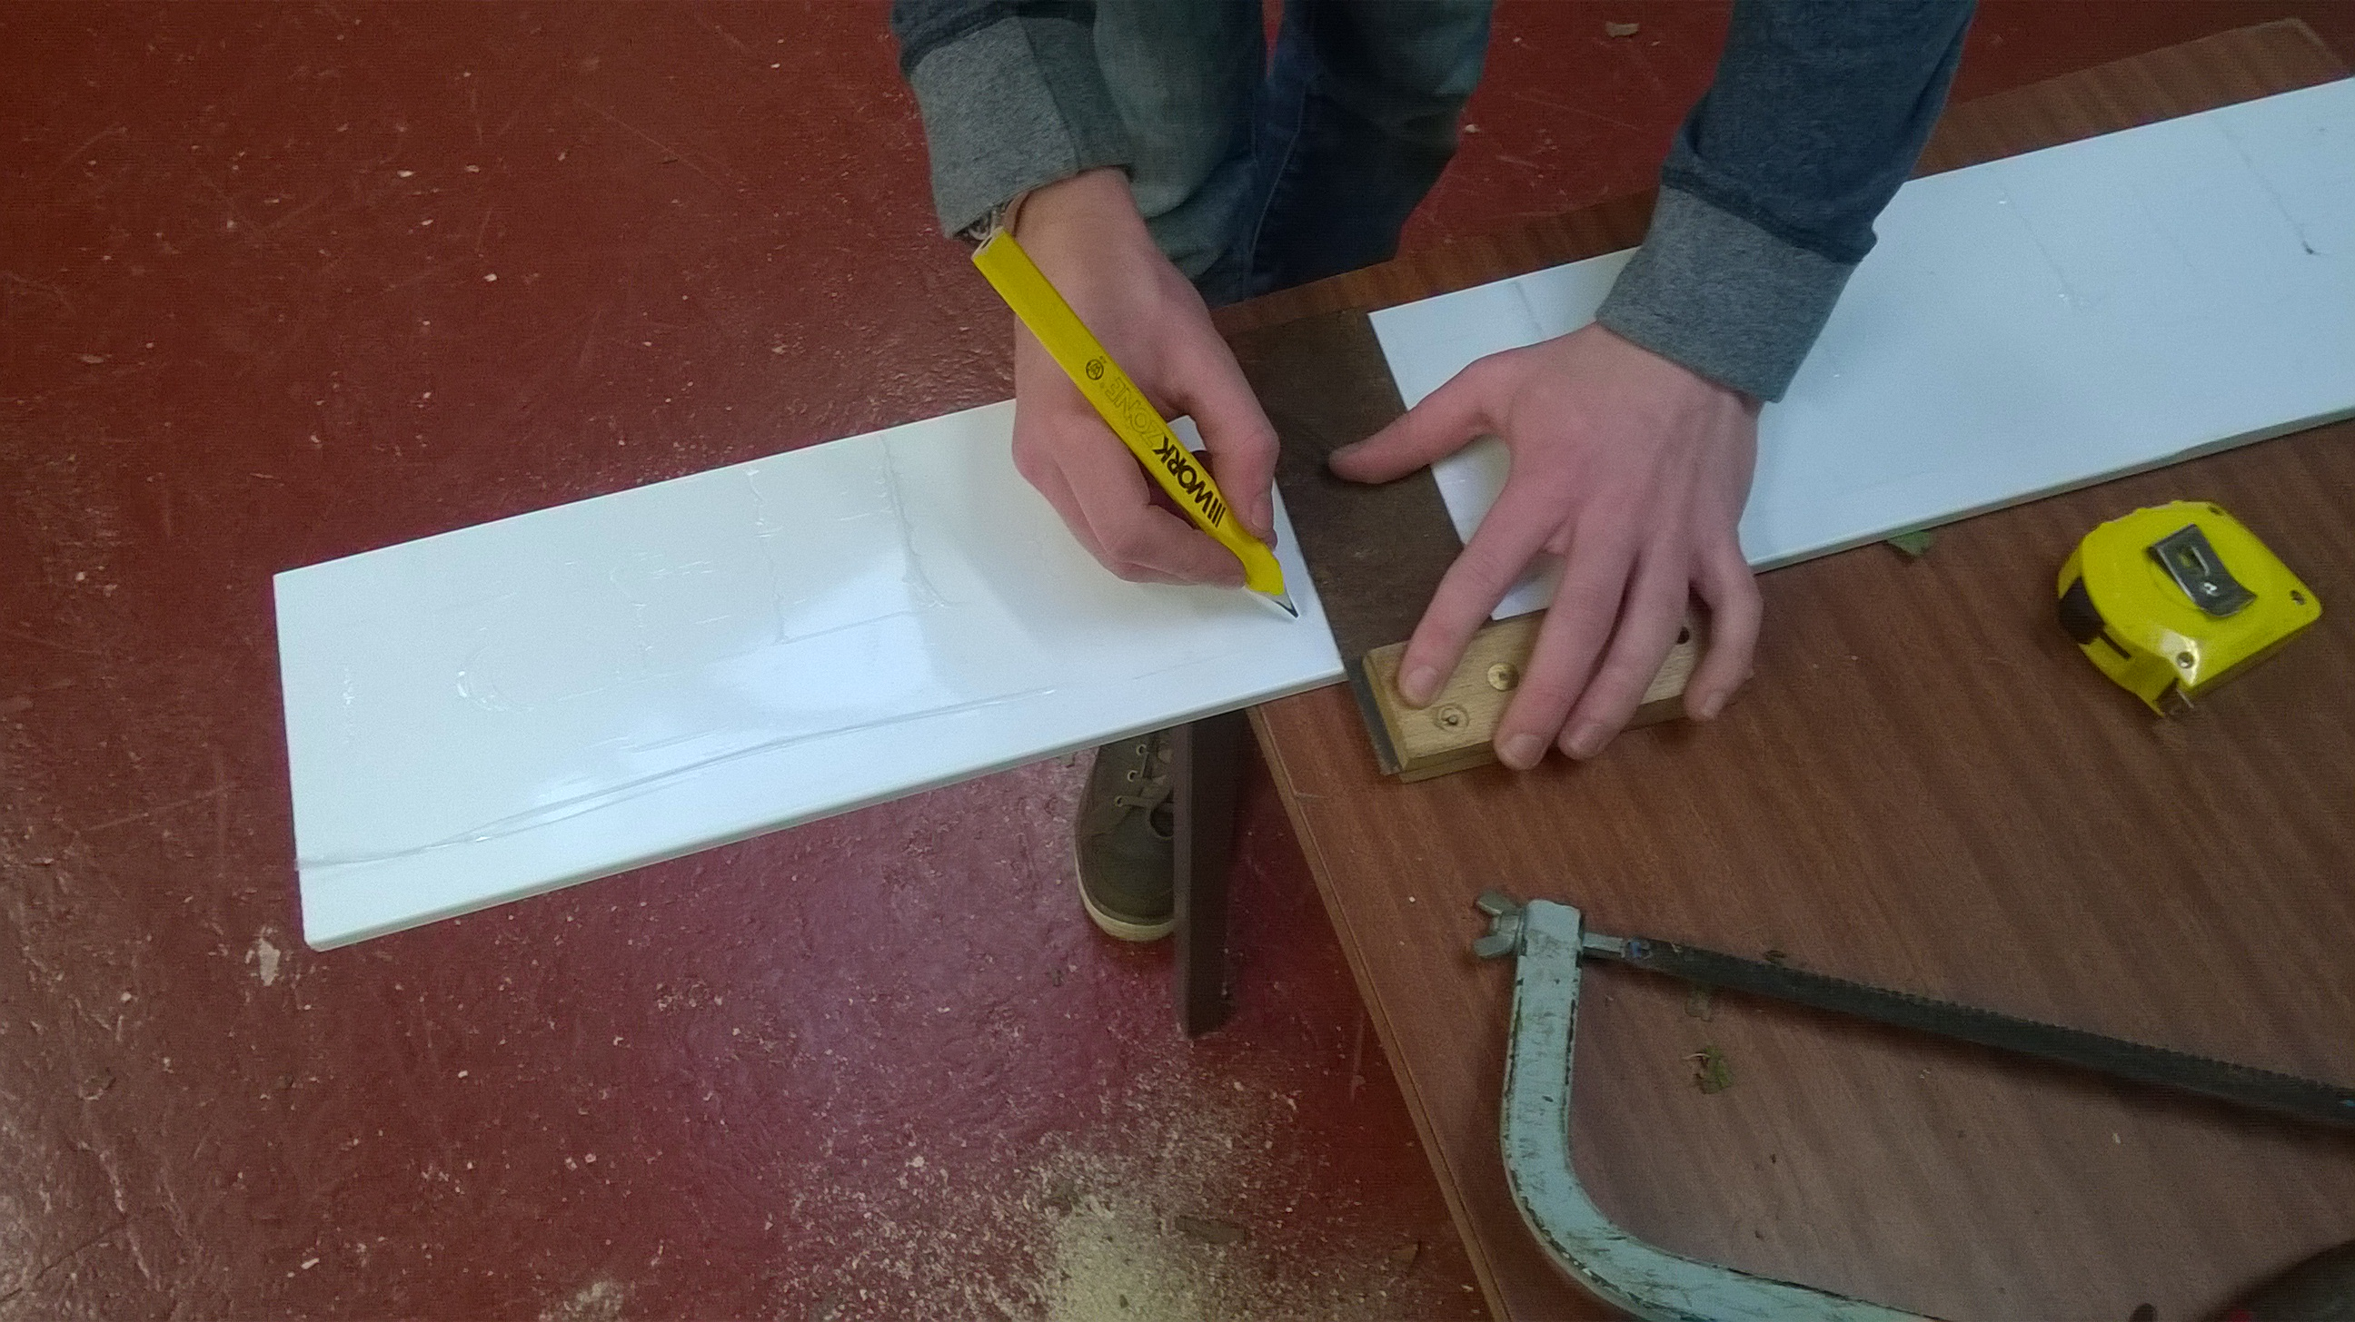

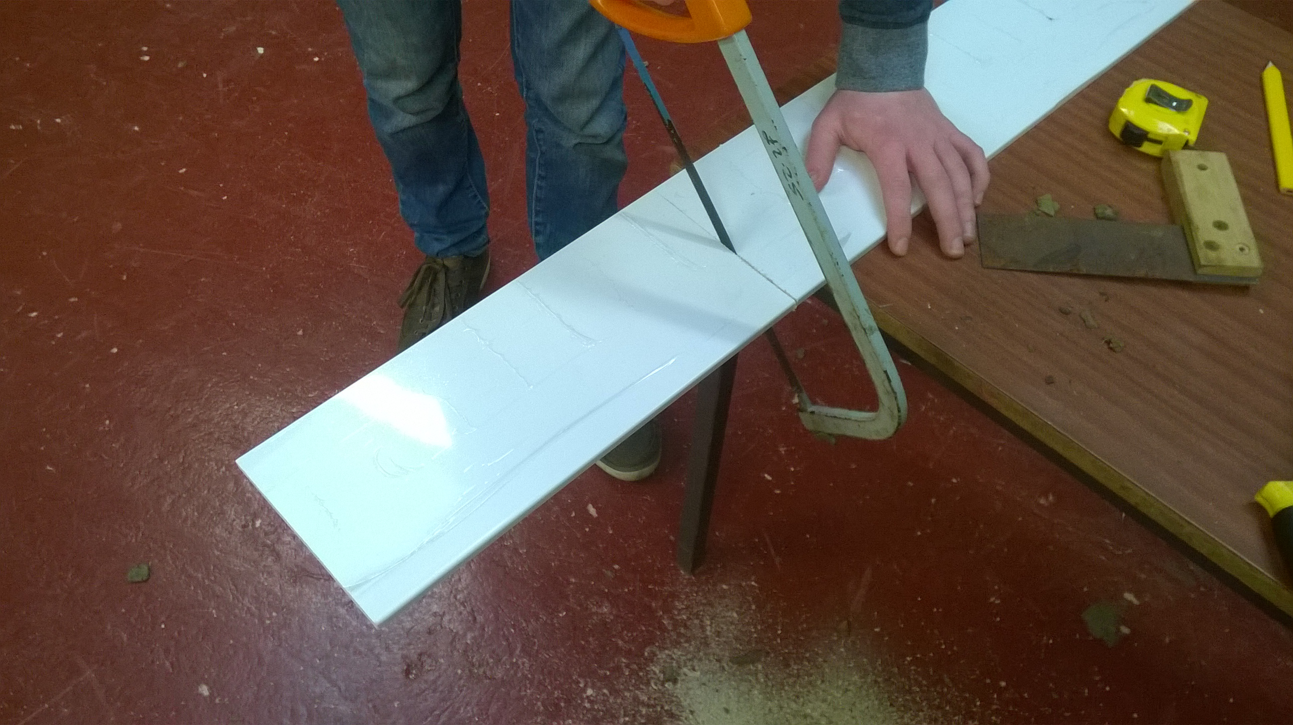

- Measure, mark (using the pencil and set square) and cut the 170cm wooden plank to the following lengths: 3x 30cm, 2x35cm using the timber saw.
30cm
30cm
30cm
35cm
35cm

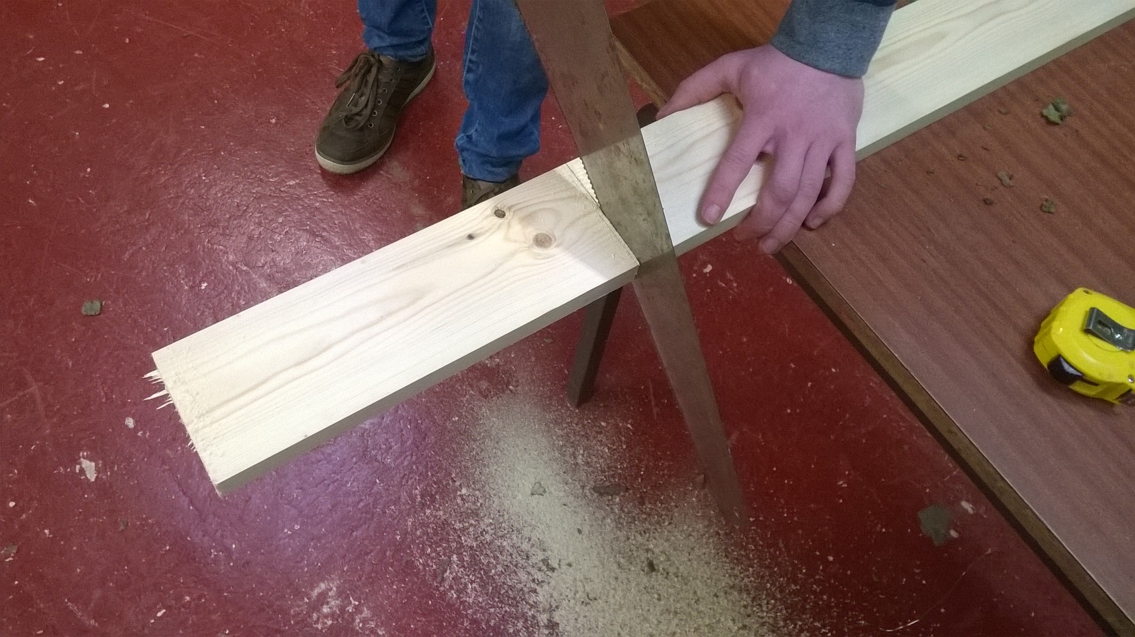
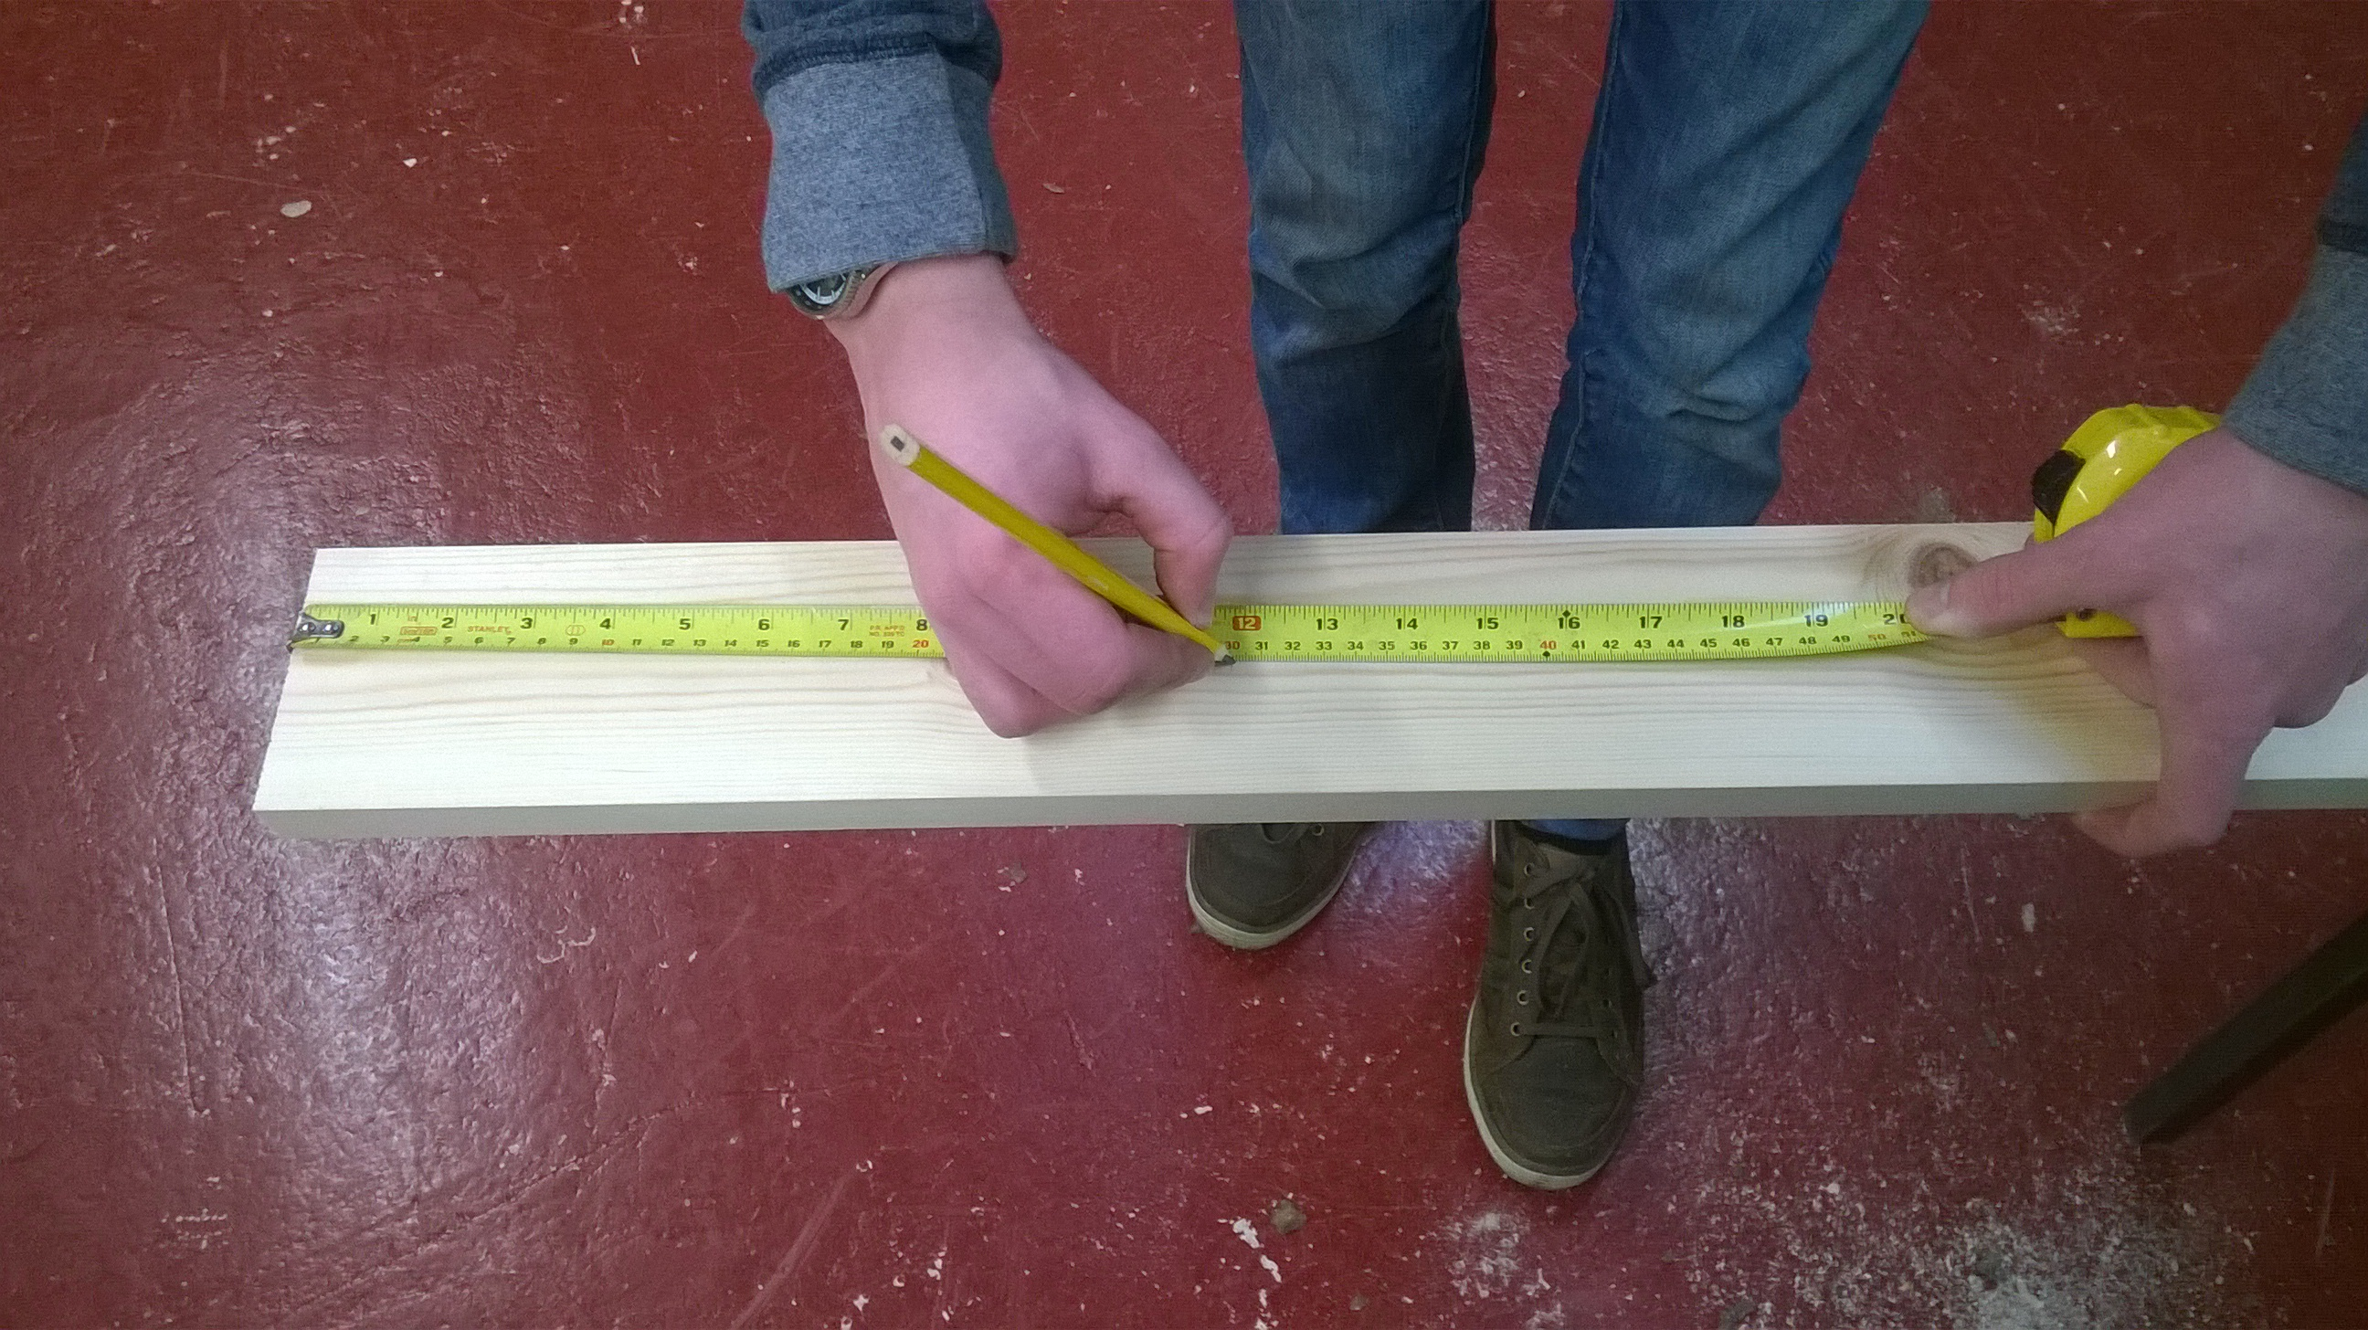
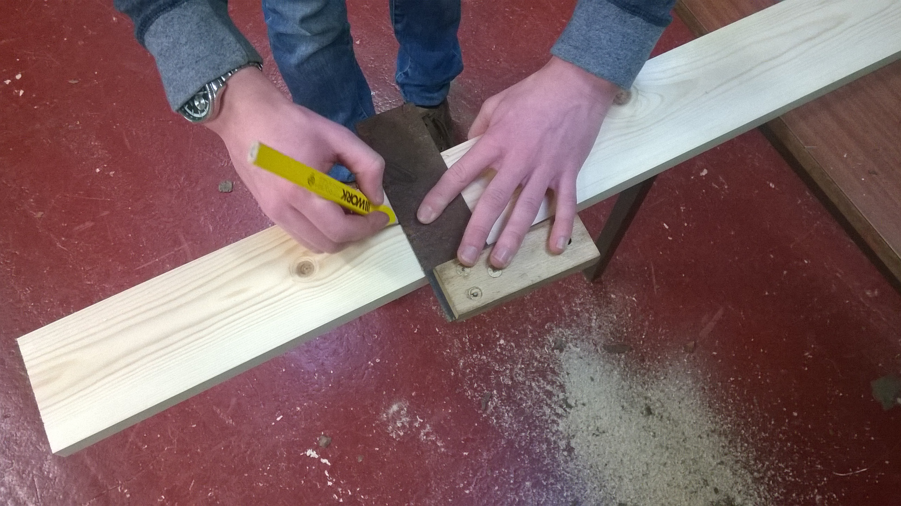

- Measure 7cm down one side of one of the 35cm planks and mark a line across (using the pencil and set square)
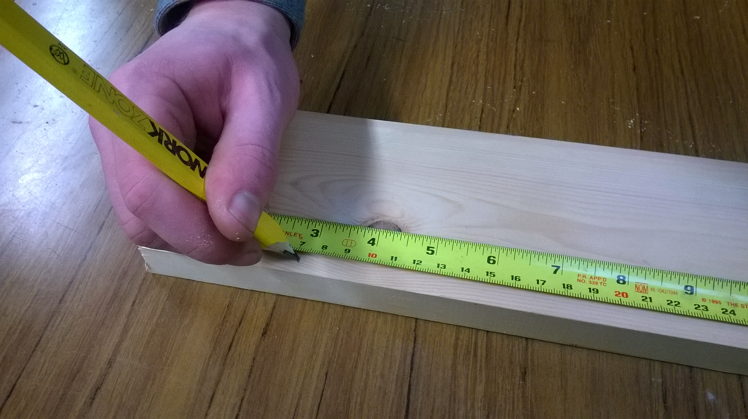
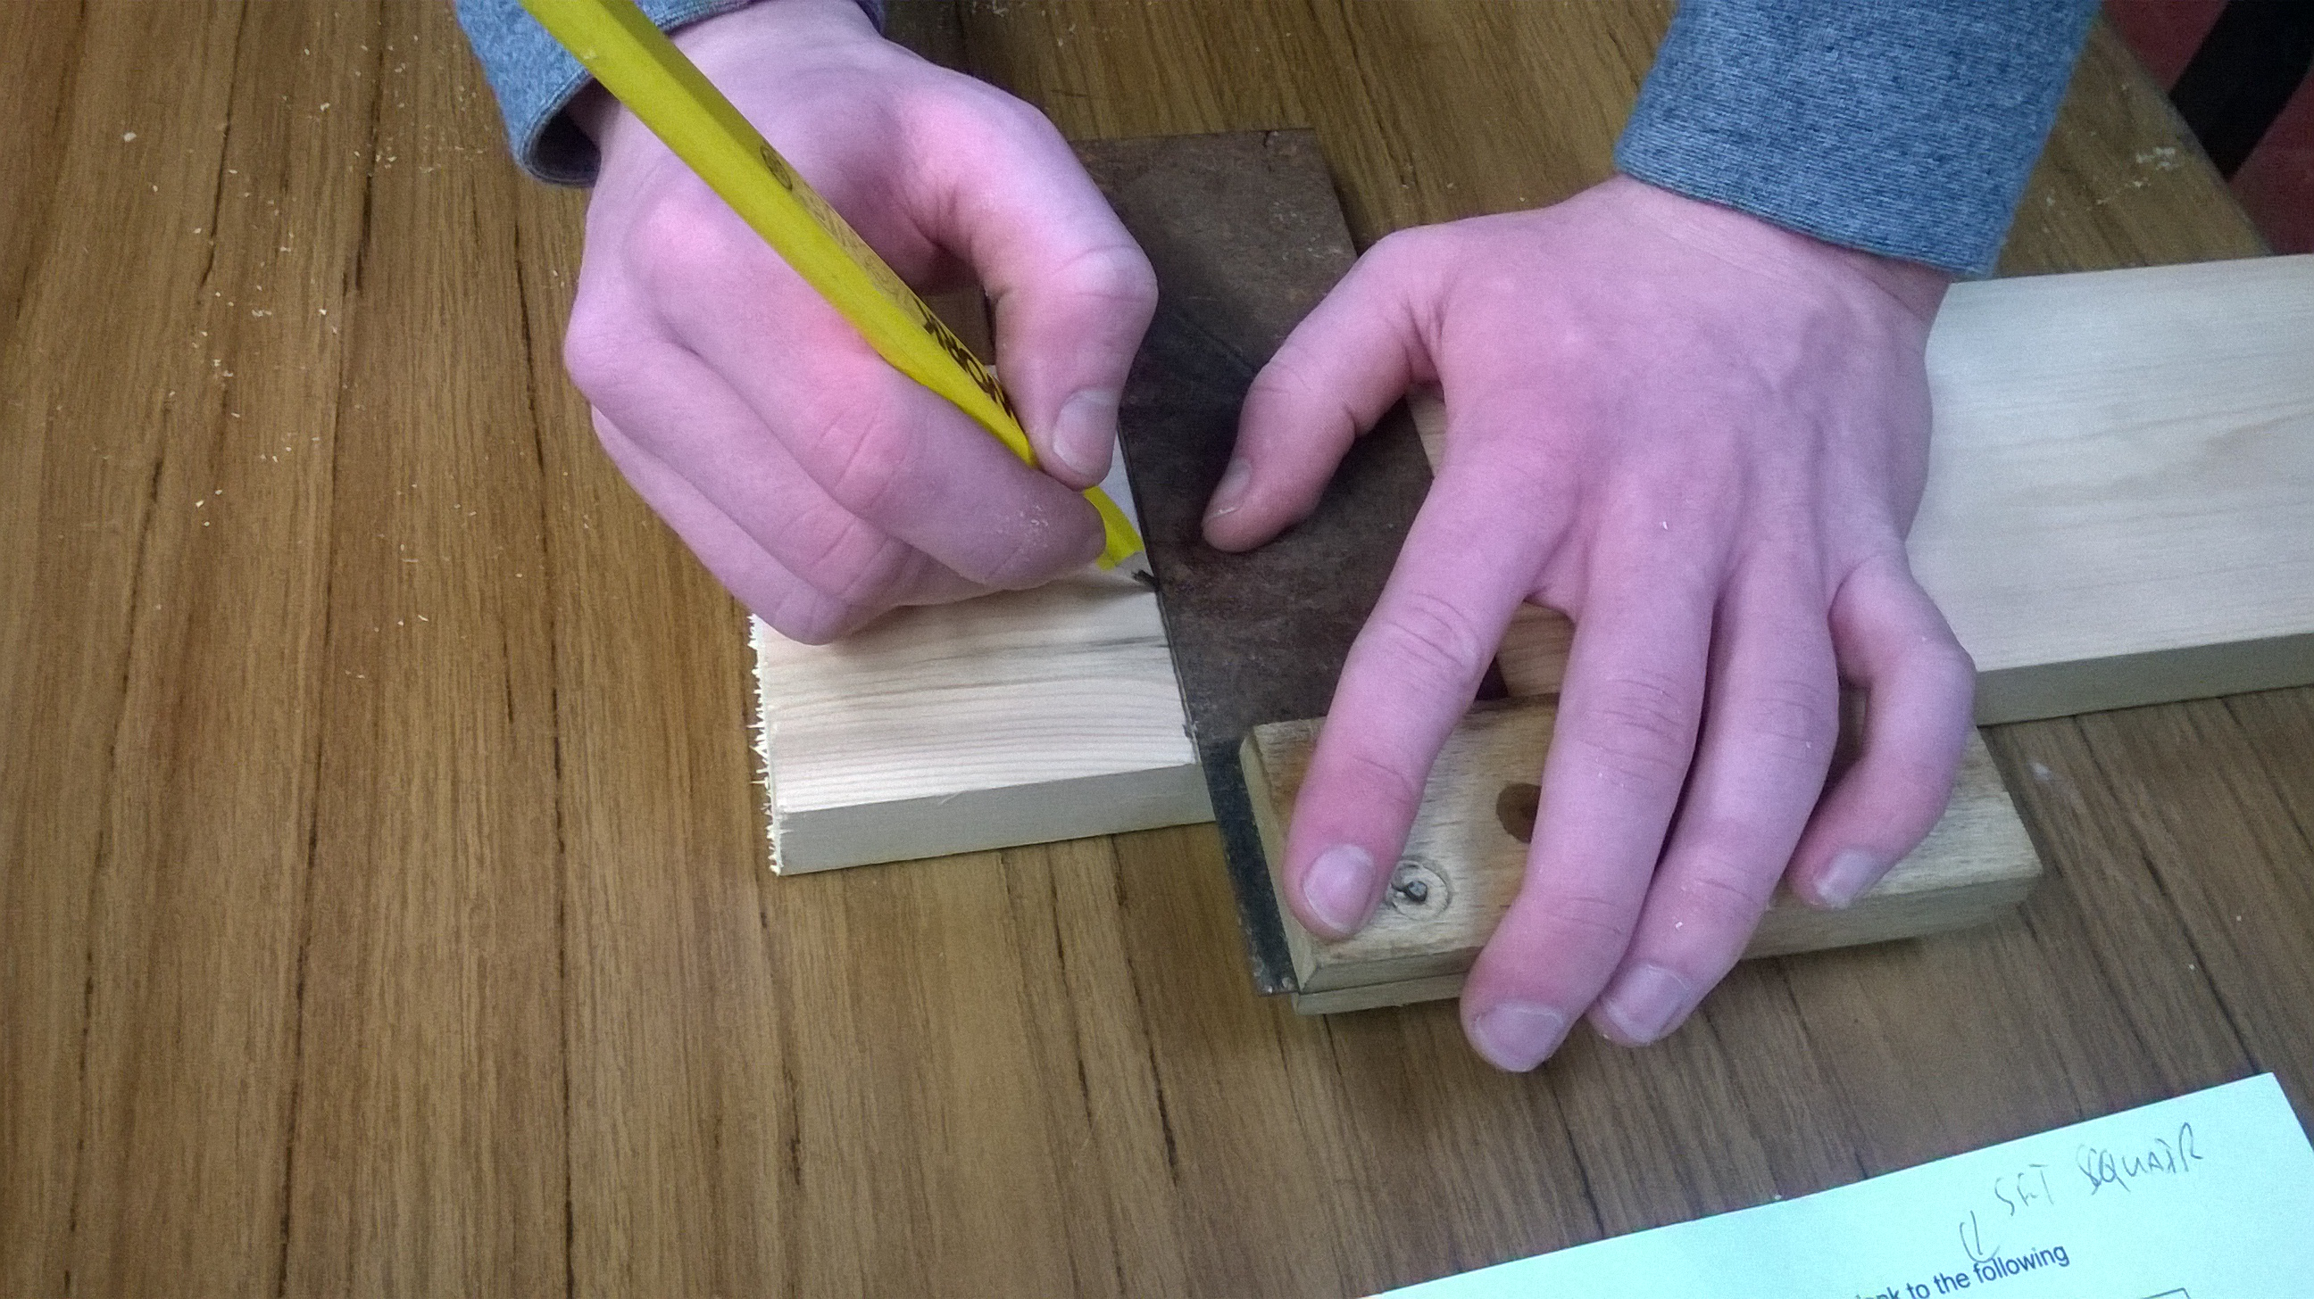

- Starting from where the previously drawn line meets the edge of the plank draw a new line diagonally across to the opposite corner using the steel rule (there should be two equally sized triangles once this is done).
Cut along the diagonal line using the timber saw leaving an angle on one end of the plank.
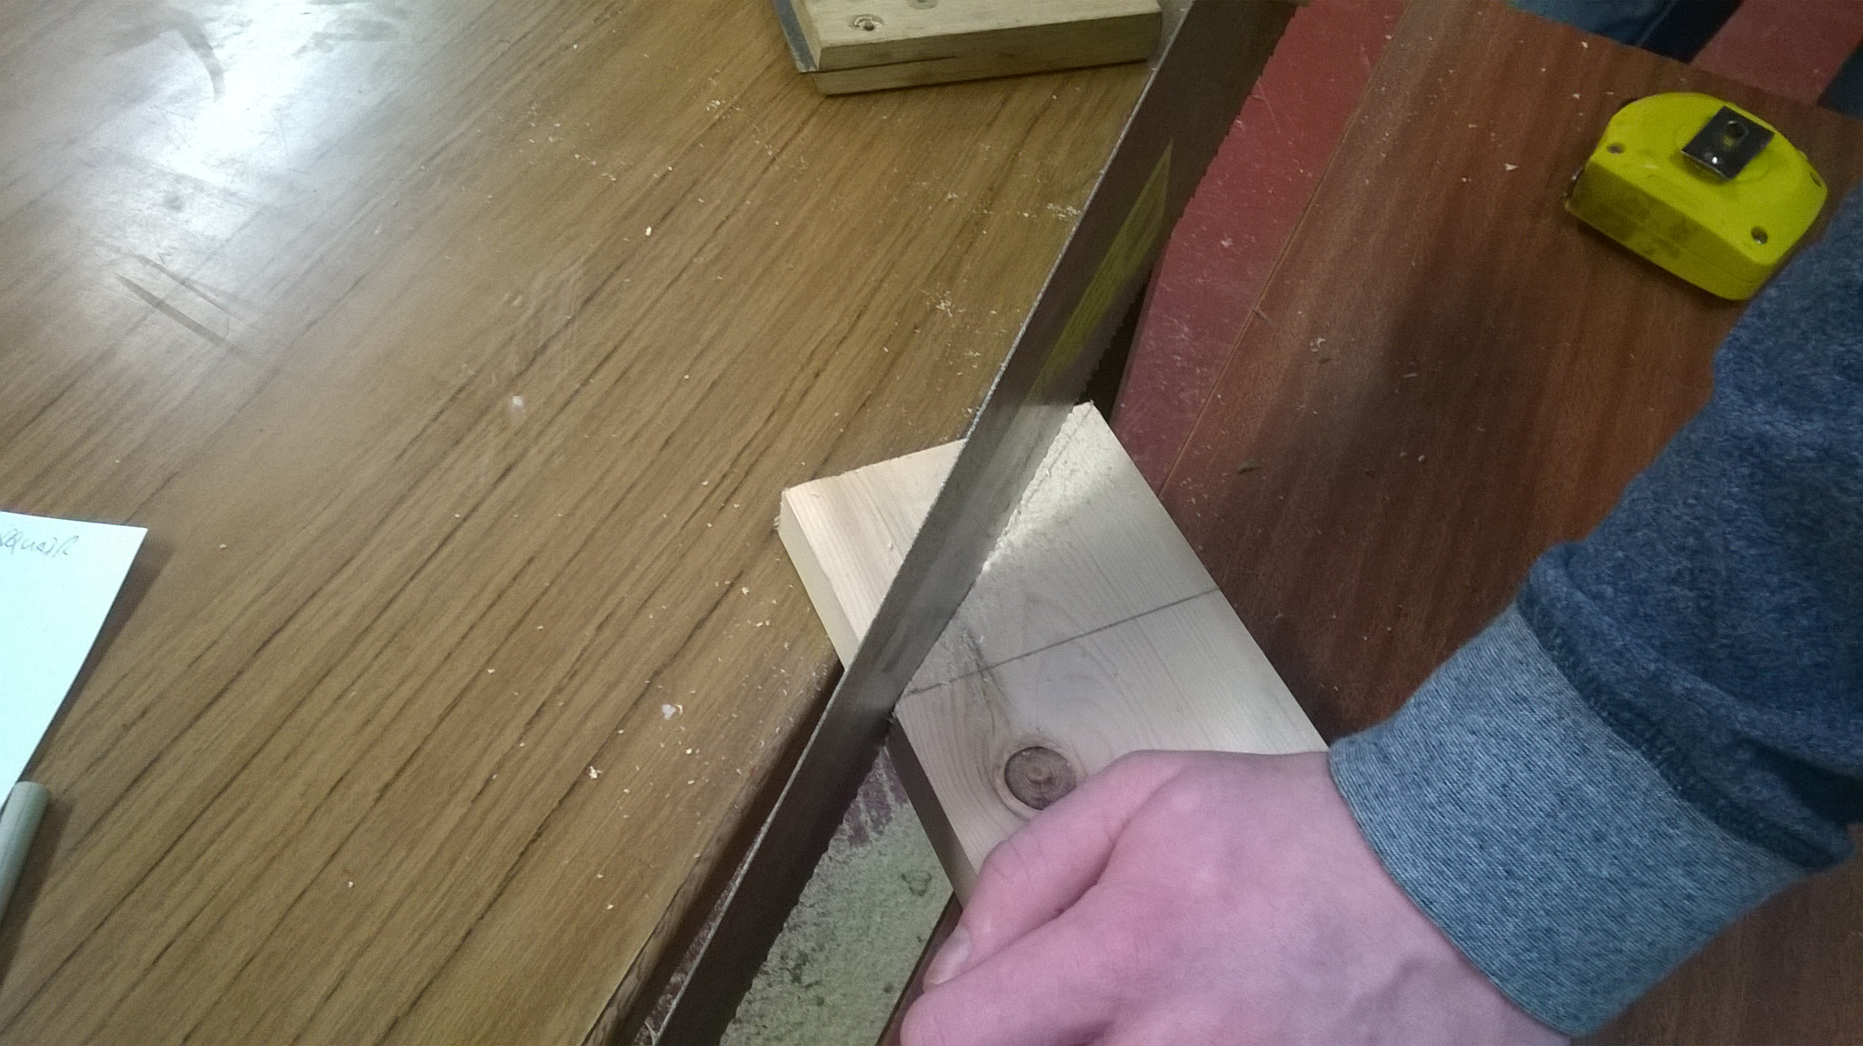
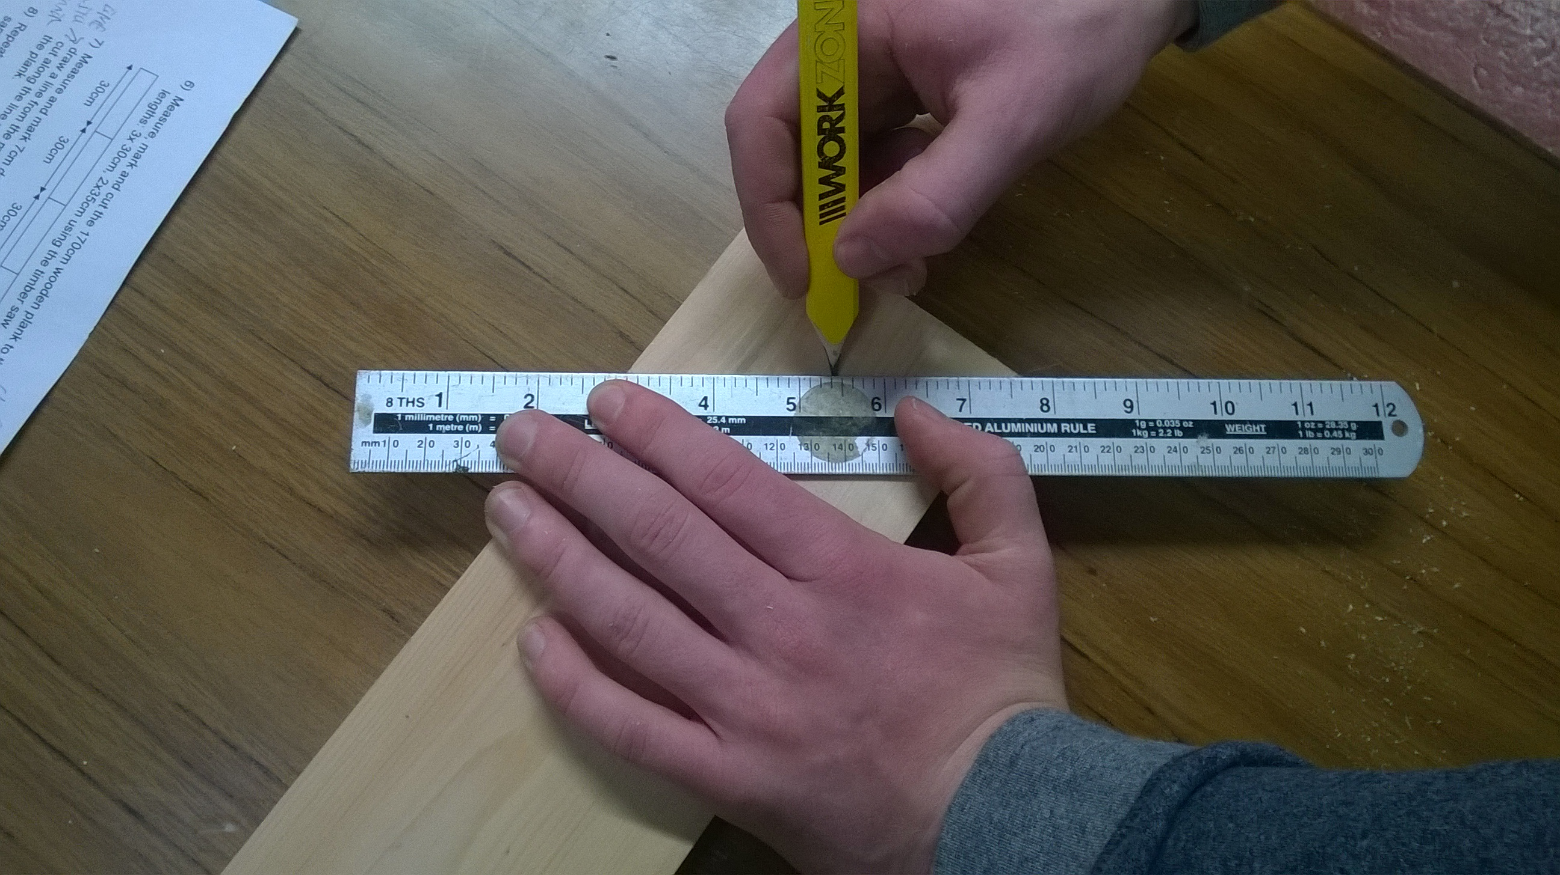

- Repeat step 7 and 8 with the second 35cm plank so that both planks look the same.

- Starting at the flat end of one of the 35cm plank measure and mark 1cm and 12cm, draw lines across at the marks using the set square.

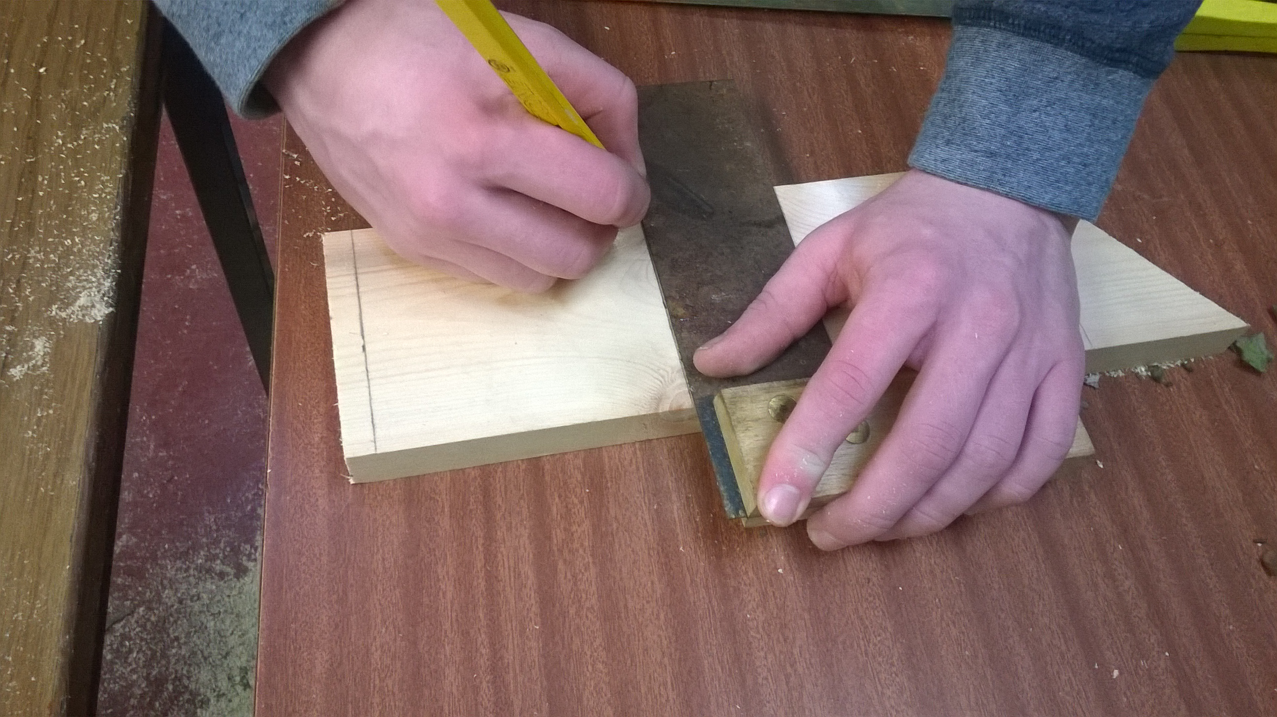
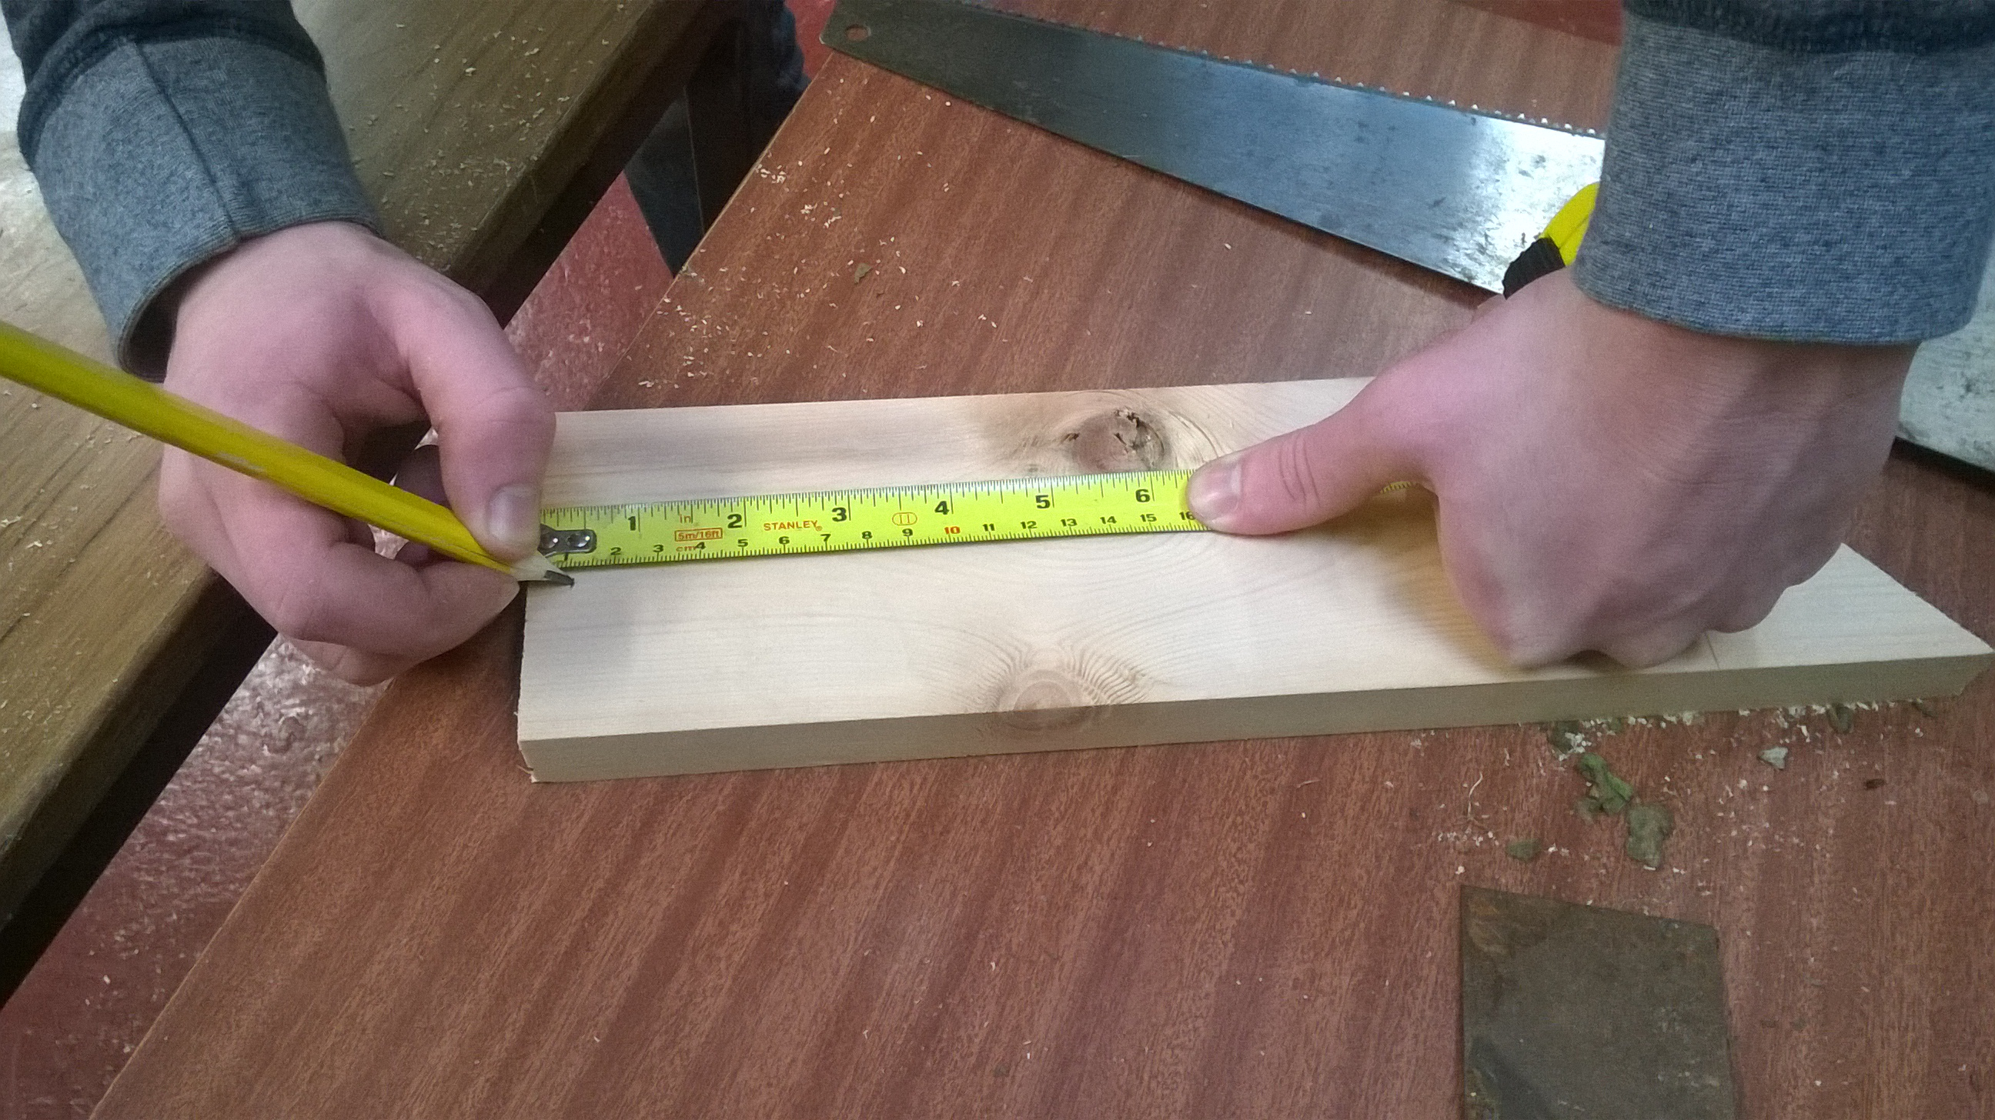

- Mark two Xs on each line you have just drawn, 2cm from either side of the plank, drill holes through the four Xs using the 4mm drill bit.
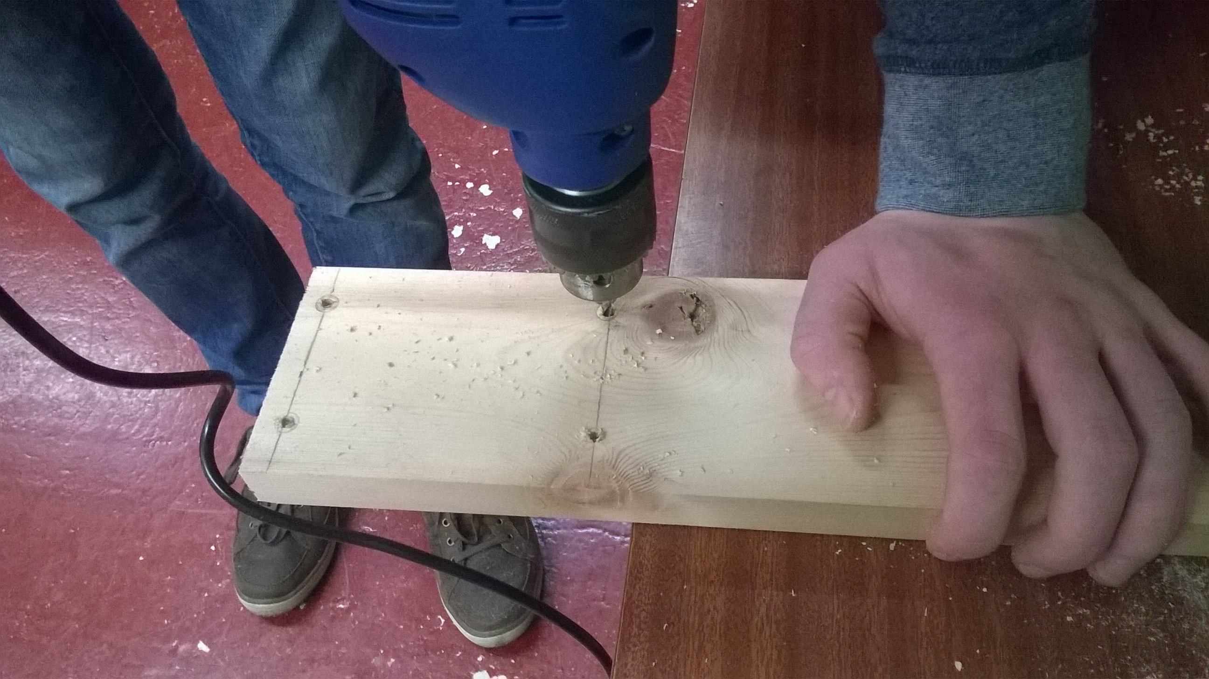
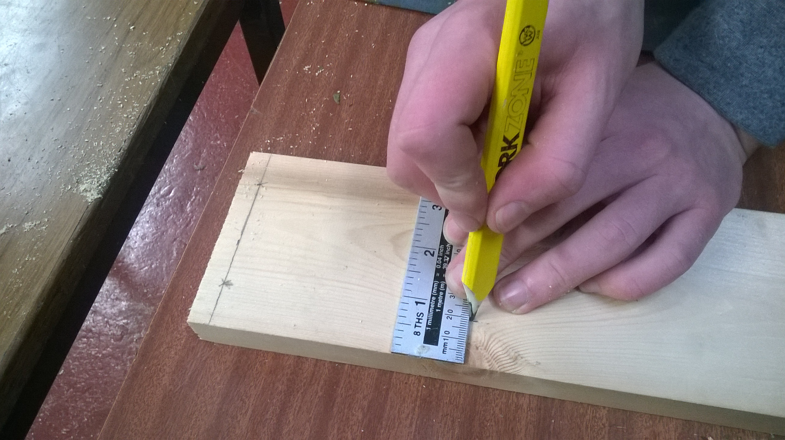

- Repeat steps 10 and 11 with the second 35cm plank so that both planks look the same.
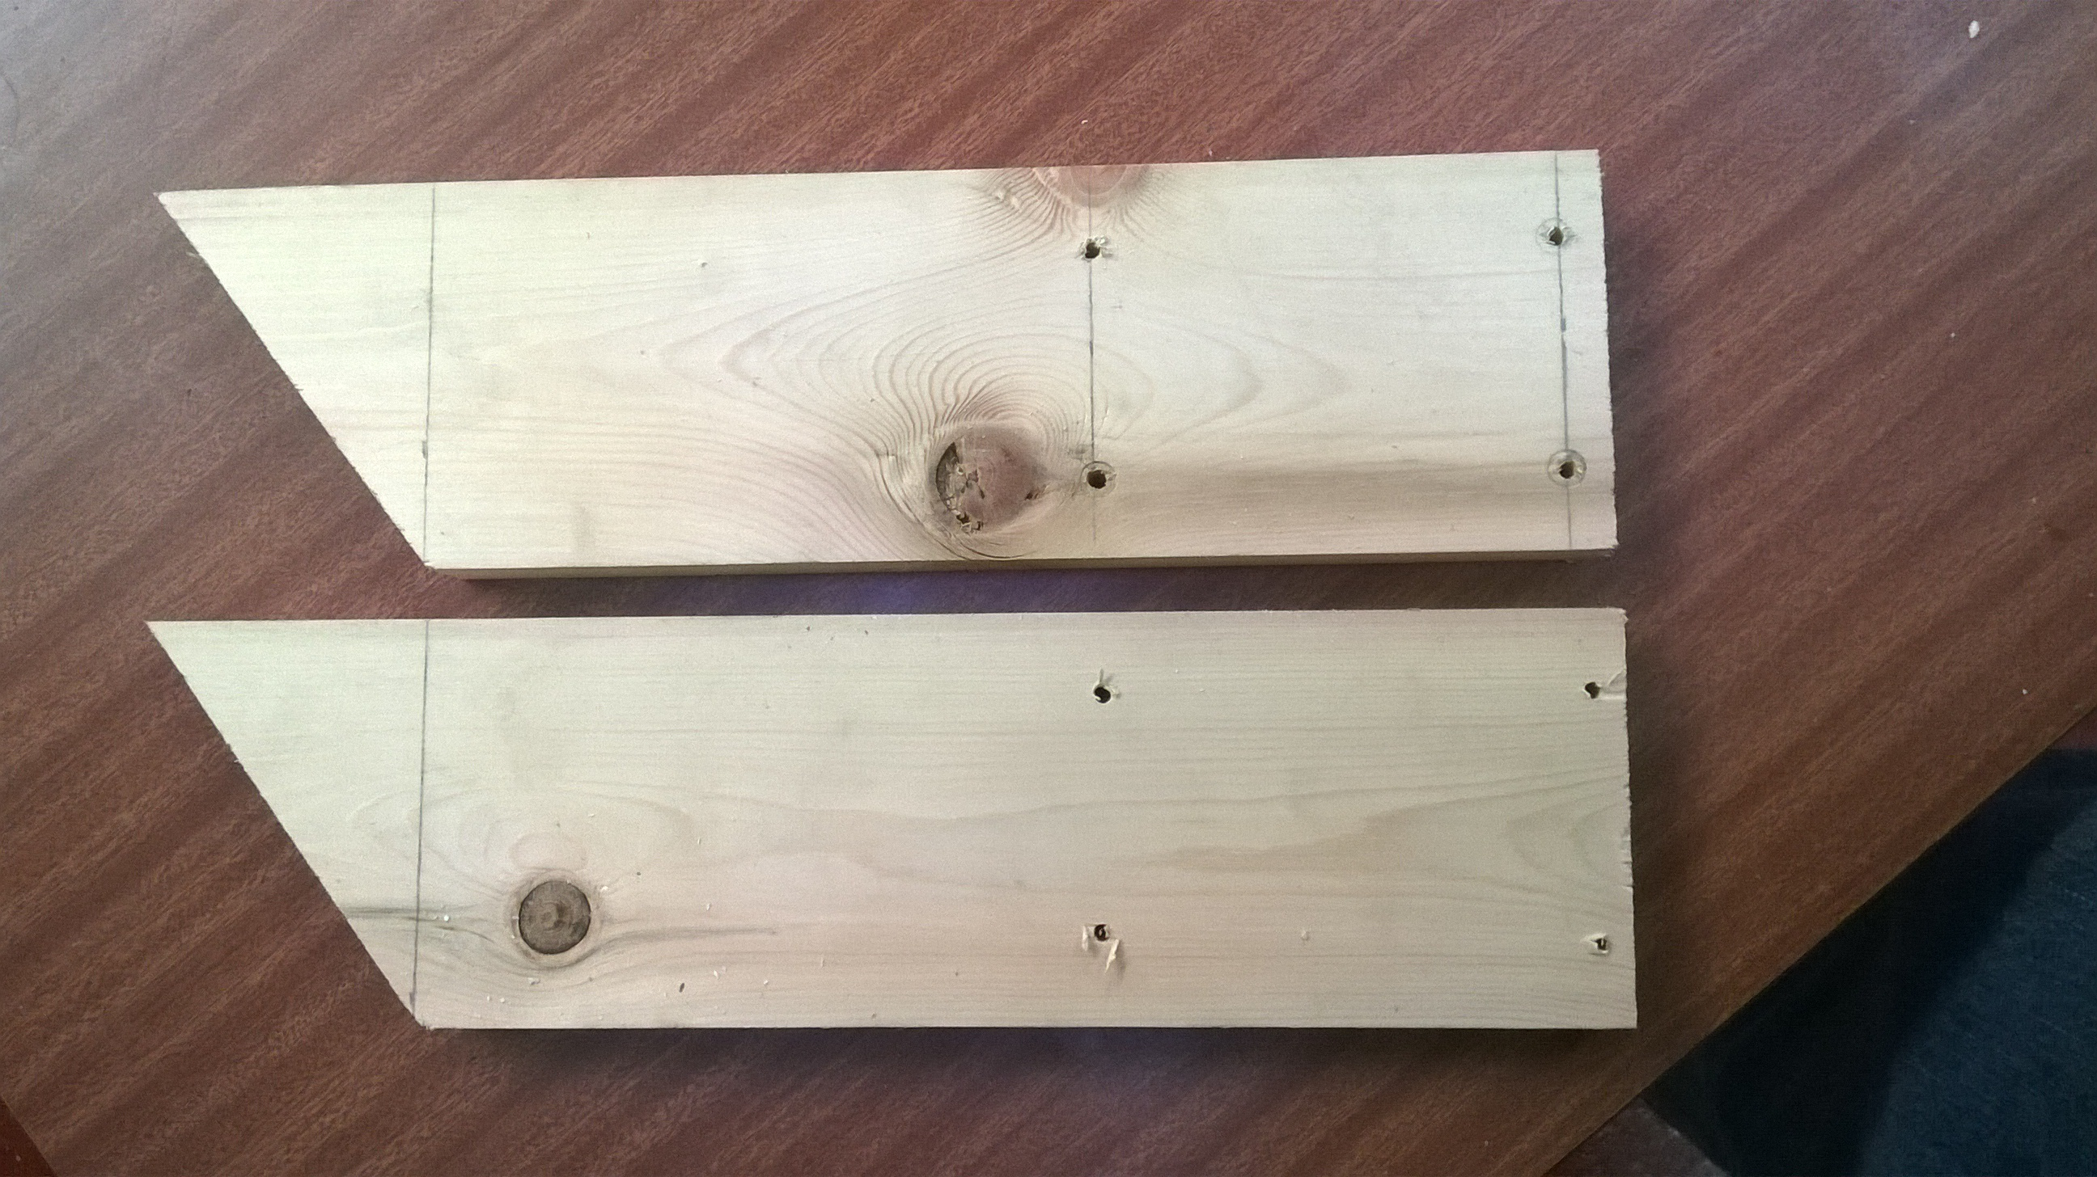

- Measure and mark (using the pen and set square) a line 1.5cm from either end of the plastic board, do not remove the plastic film.
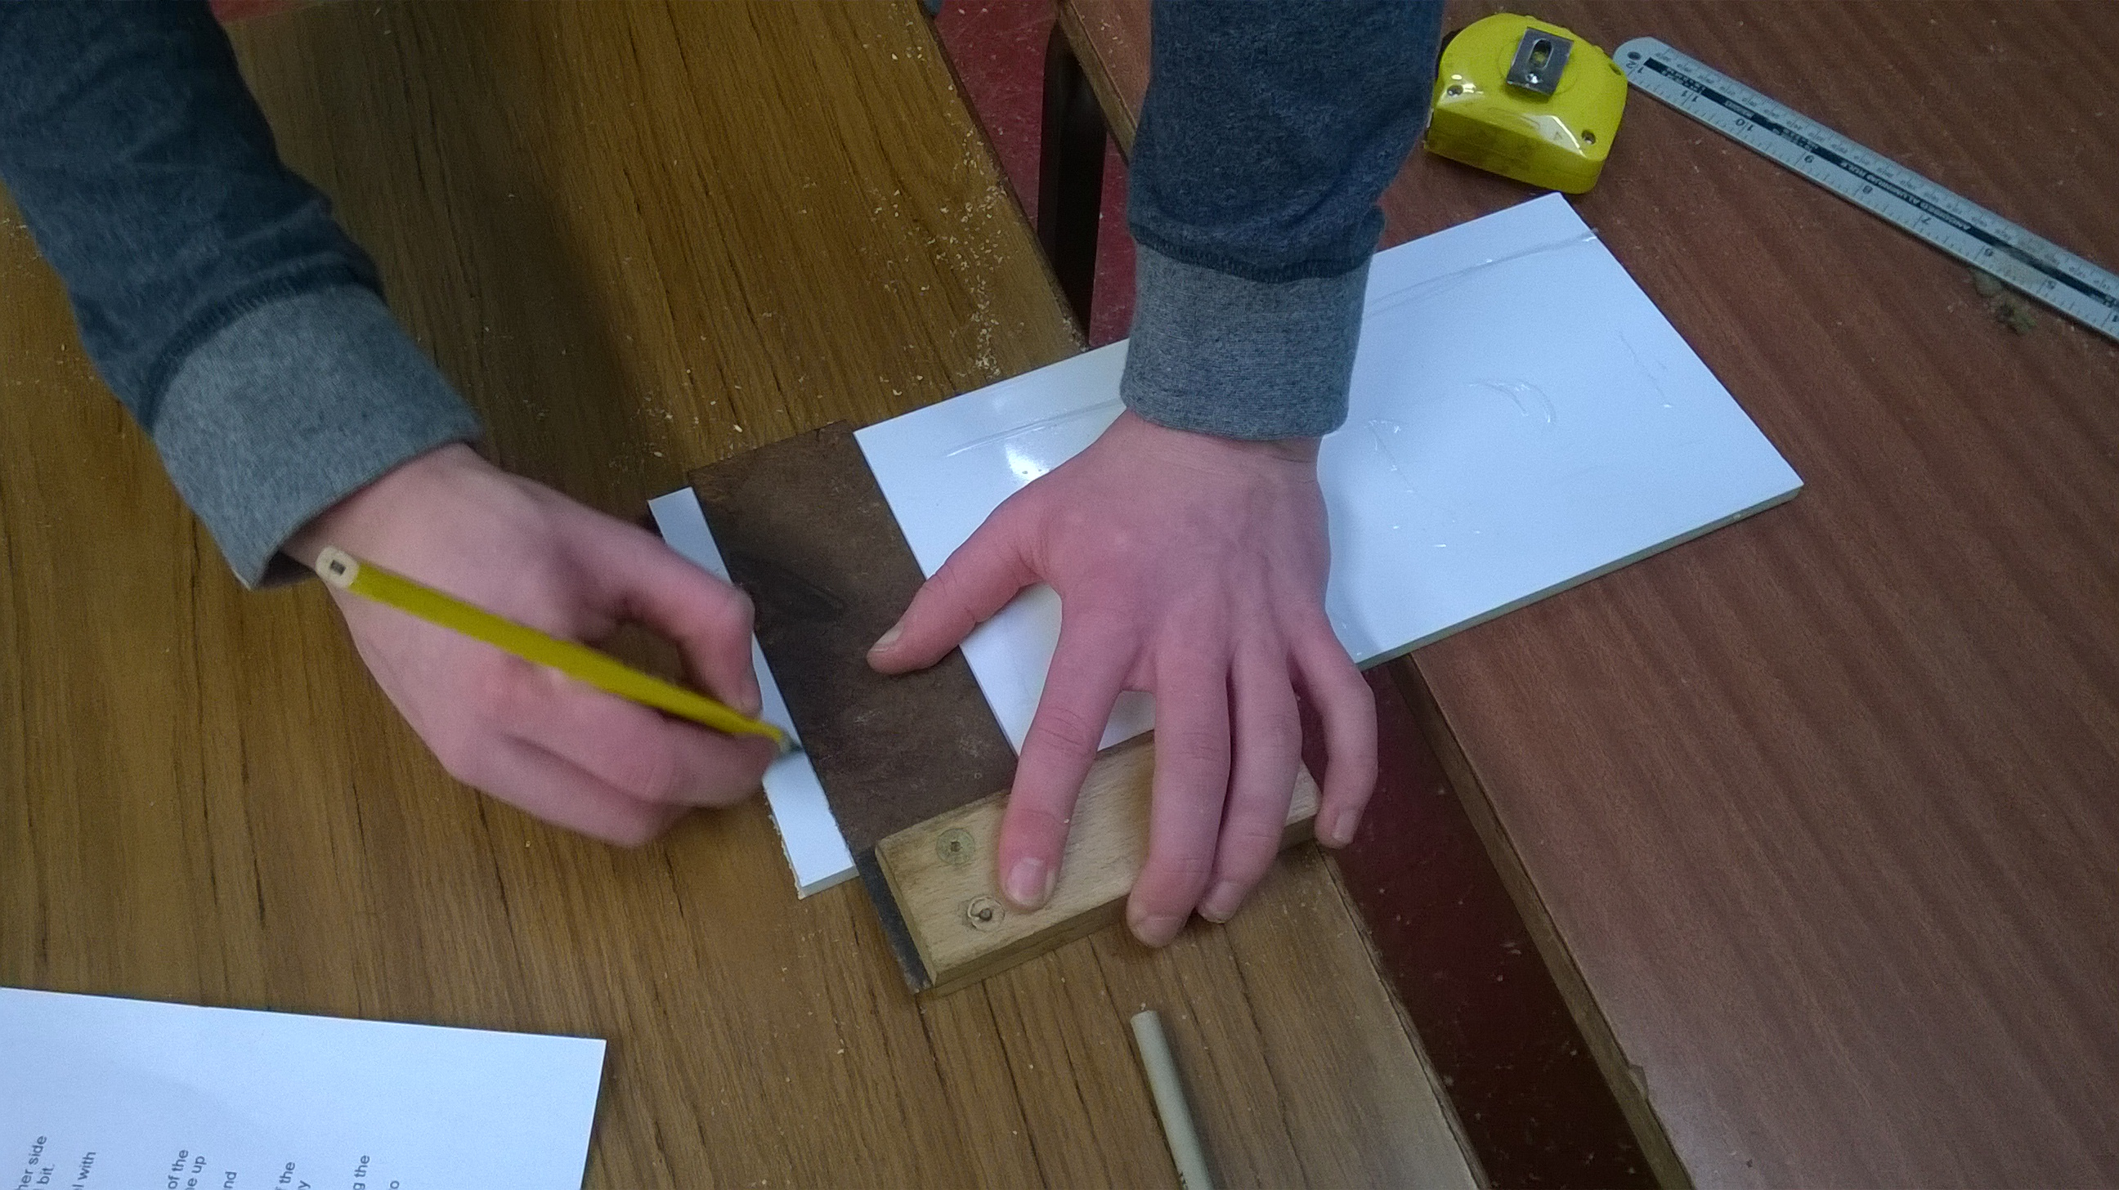
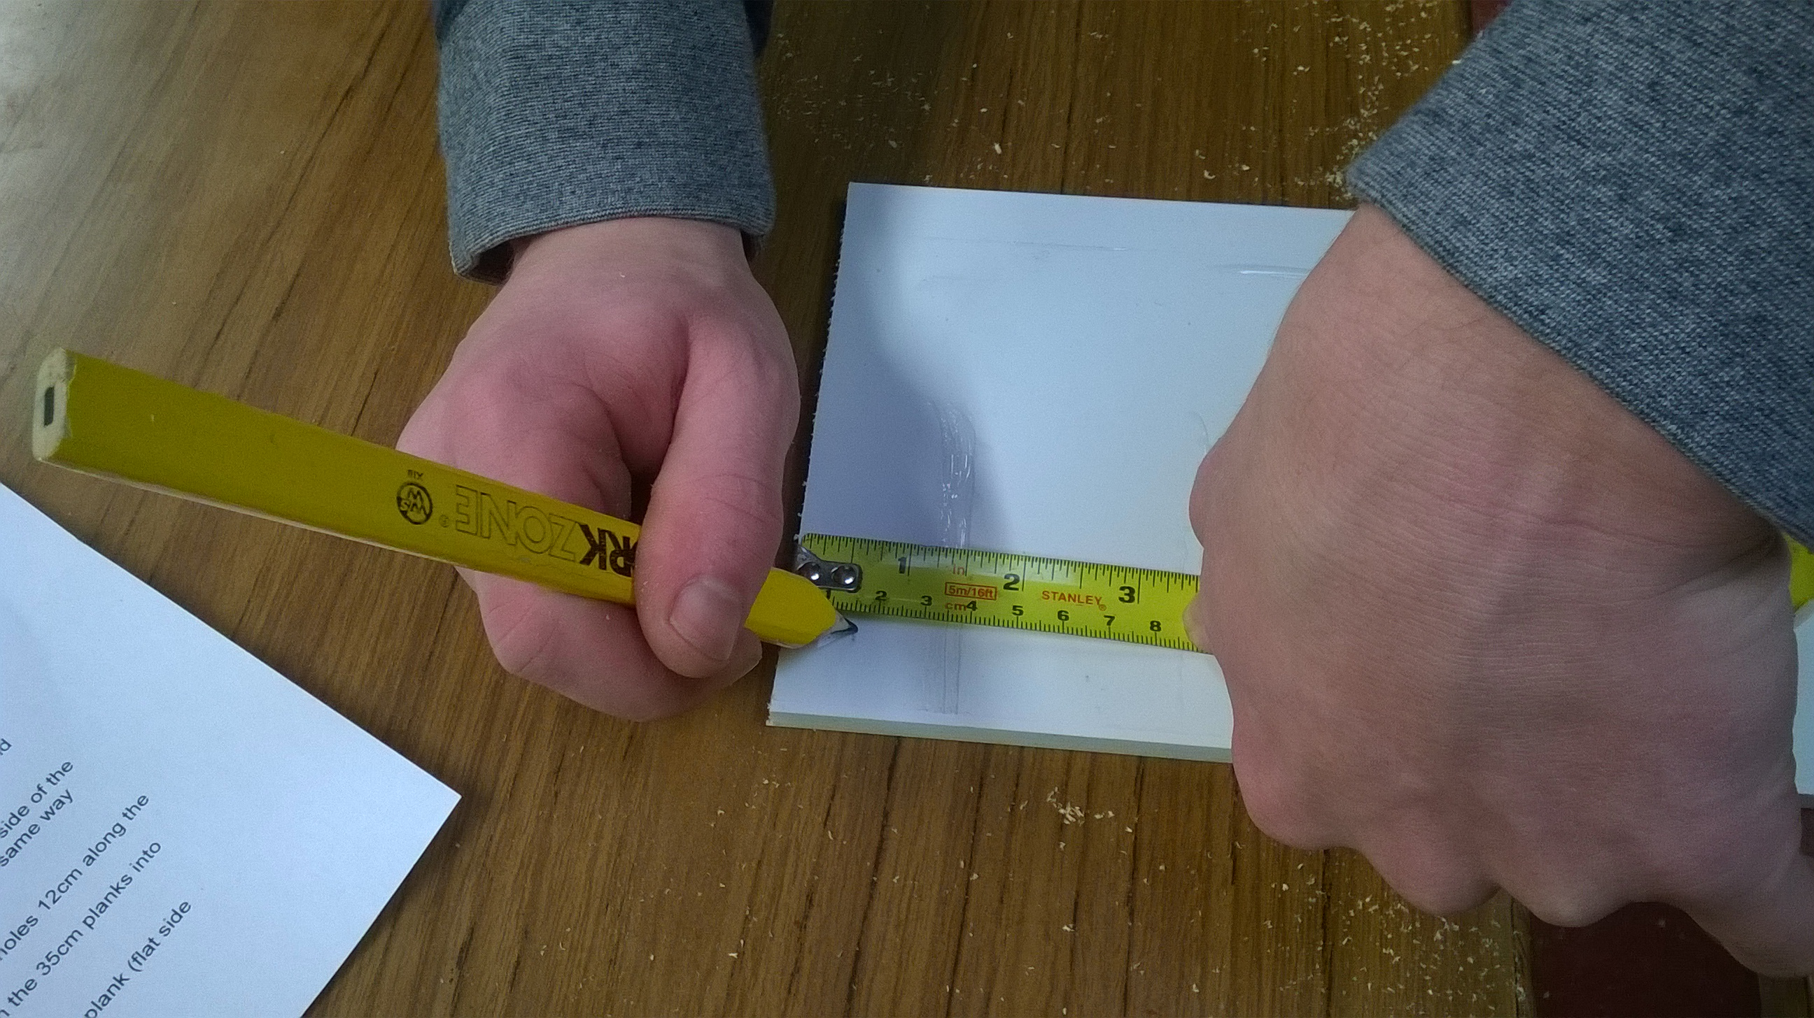

- Mark two Xs on each line you have just drawn, 3.5cm from either side of the board, drill holes through the four Xs using the 4mm drill bit.
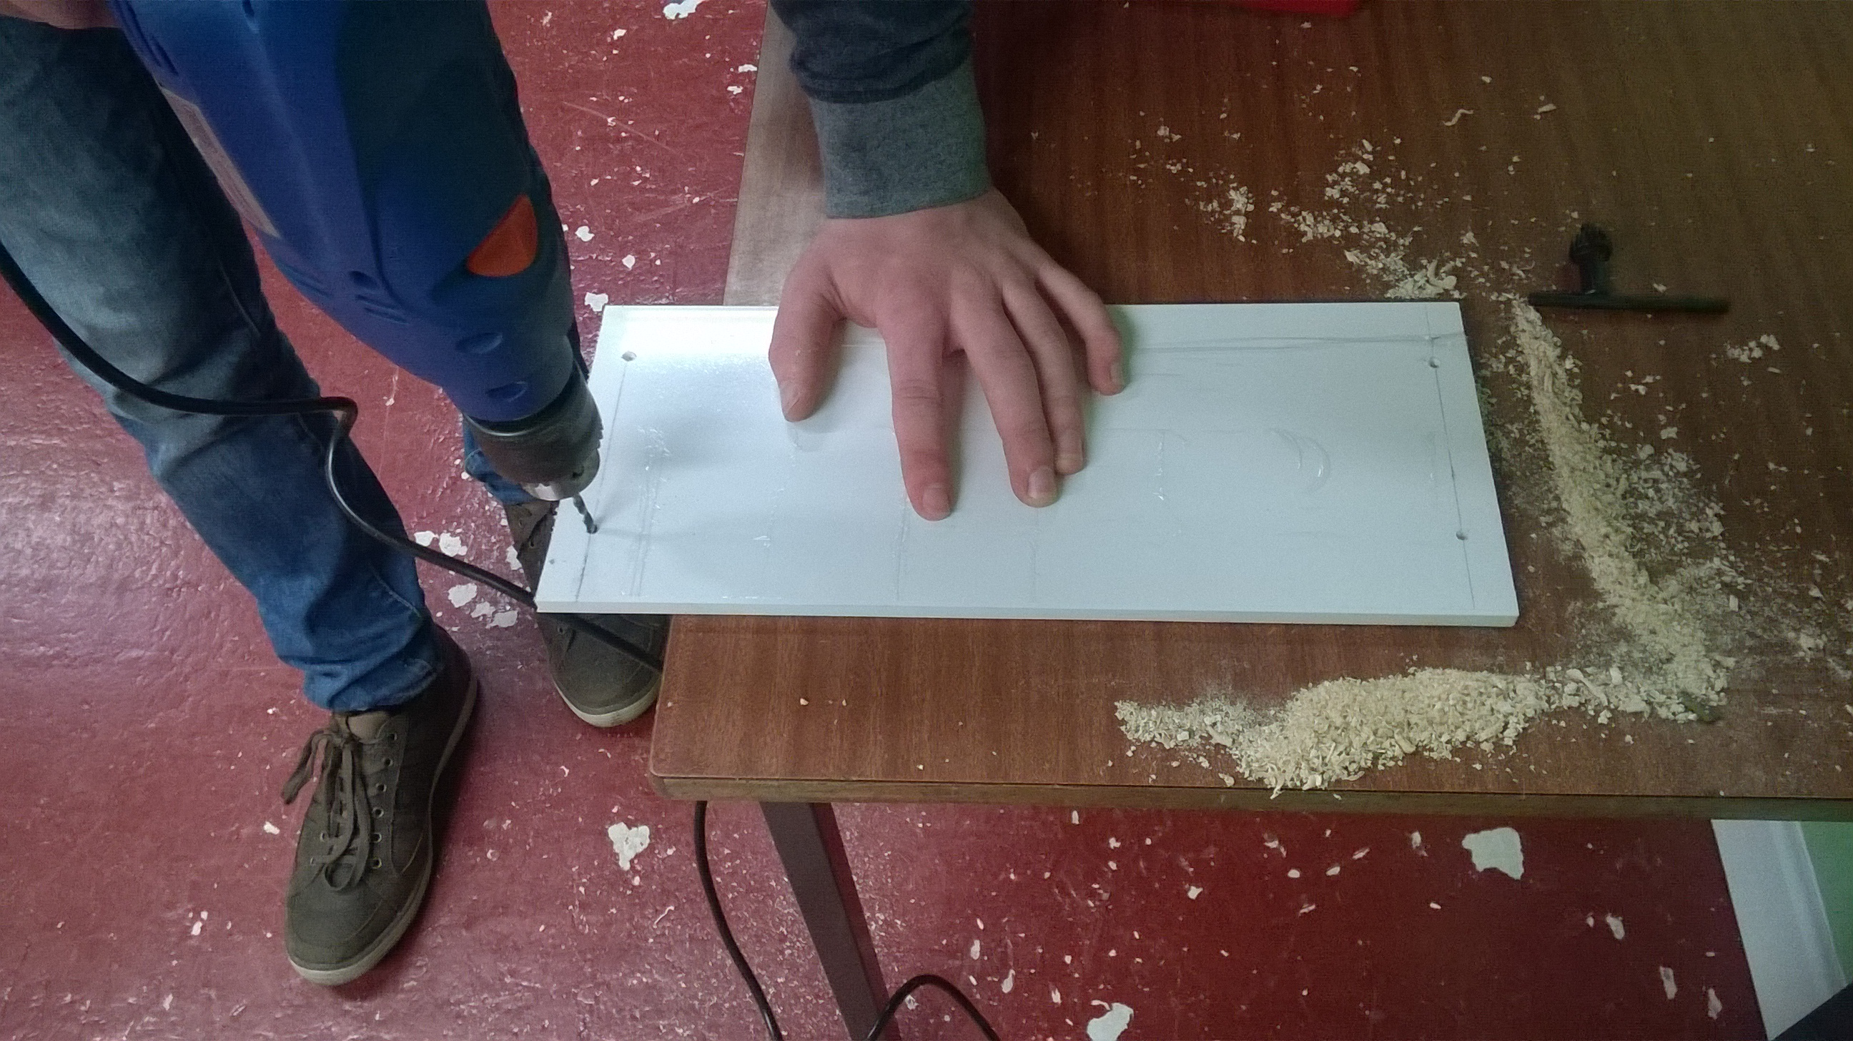
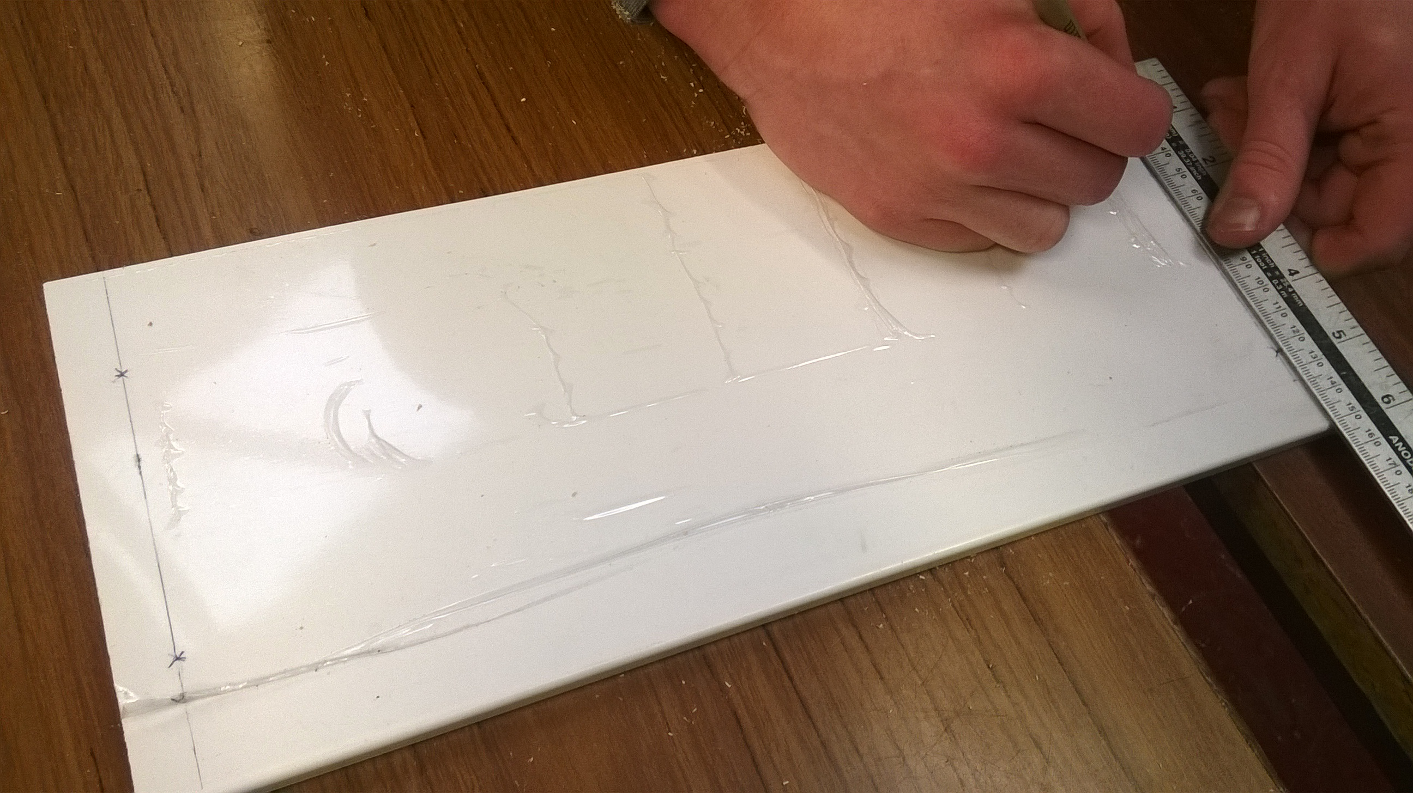

- You should now have the following items :
- 3x 30cm planks
- 2x 35cm angled planks, with 4 pre drilled holes
- 1x 36cm plastic board, with 4 pre drilled holes
- 2x split half log, drilled both ends
- 1x 27x33cm wire mesh
- 1x 35x33cm wire mesh
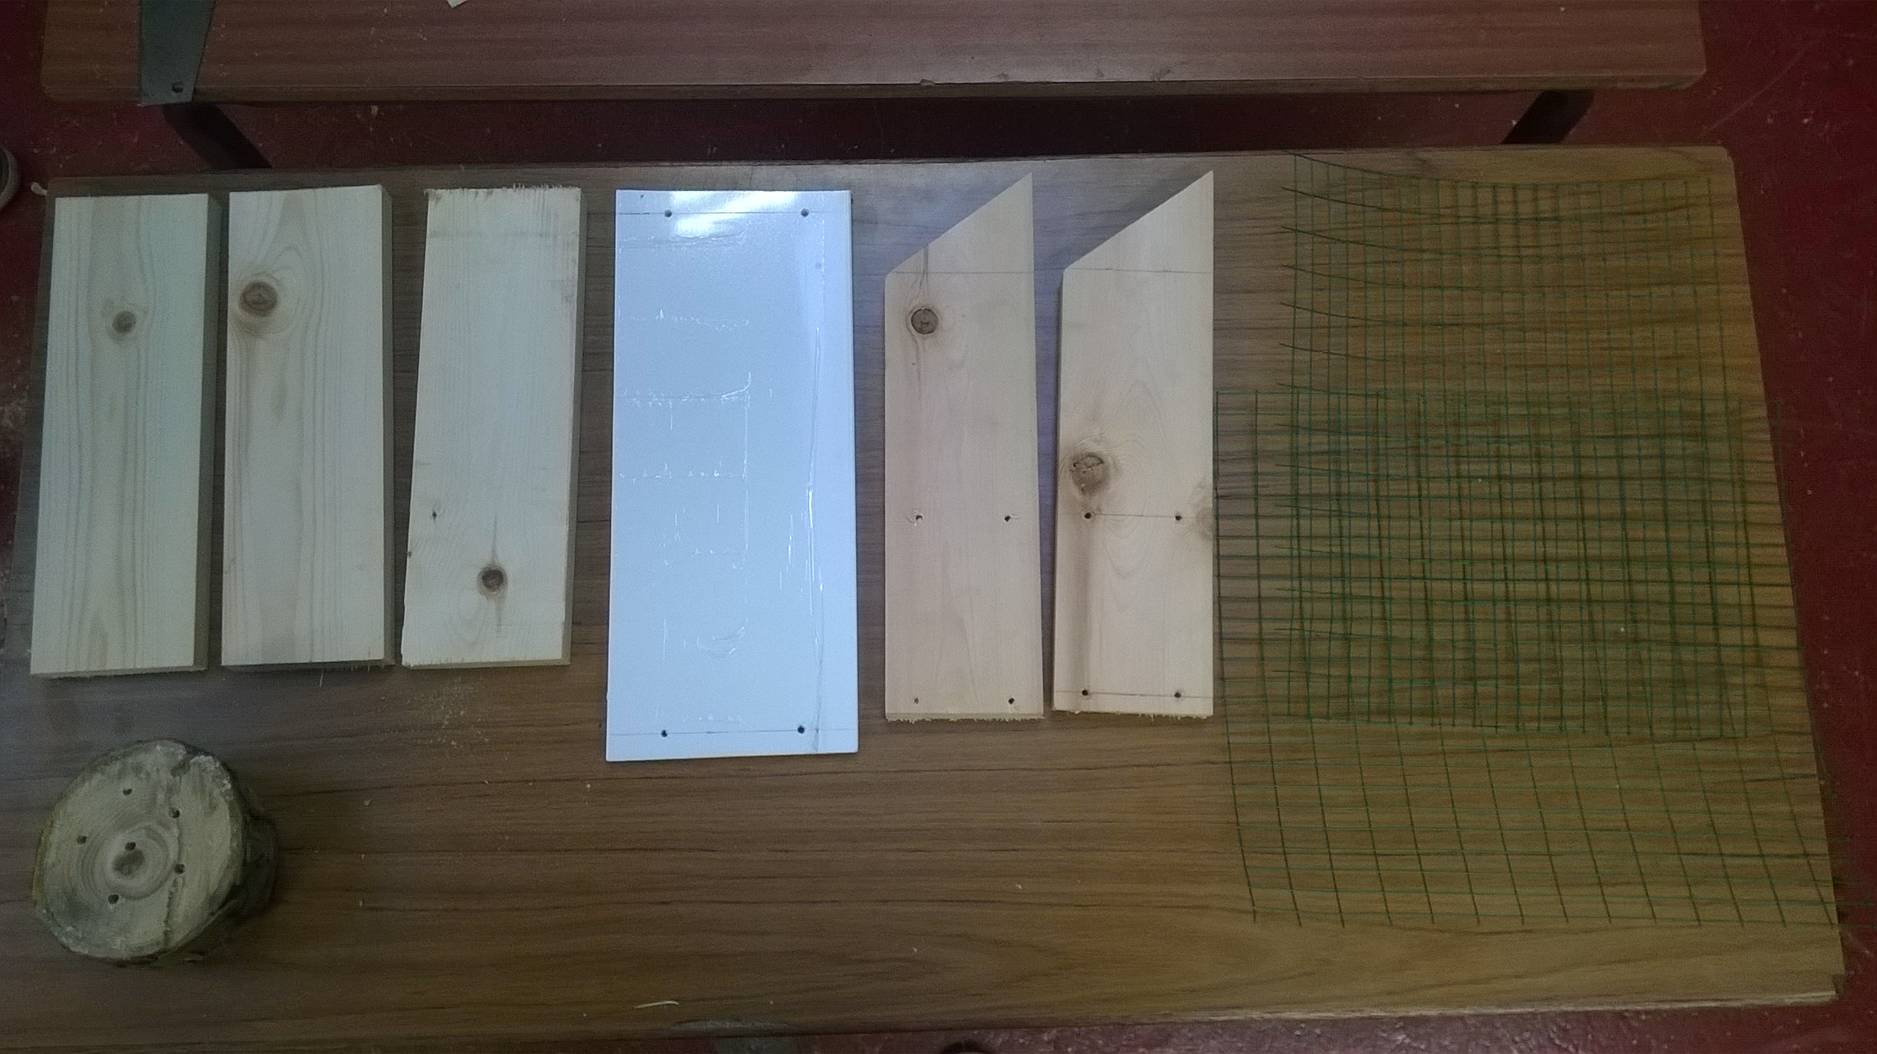

- Masking tape together the wooden and plastic boards and label with your name, put somewhere safe with the wire mesh.

