Find the insects to fill in the missing words.
Name:

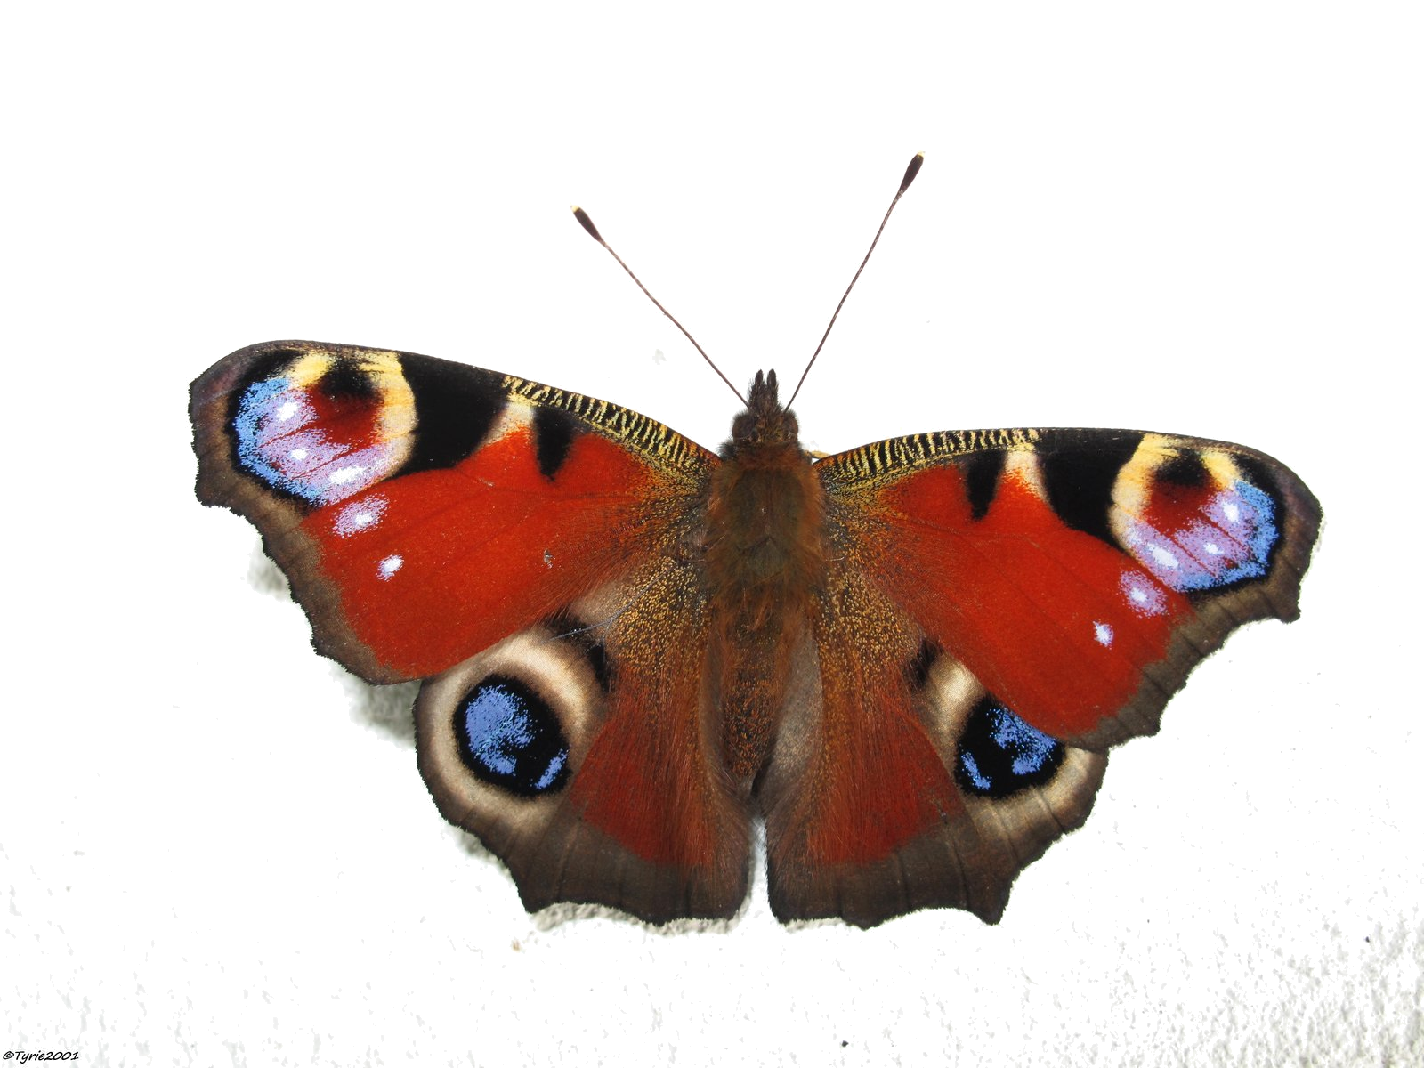
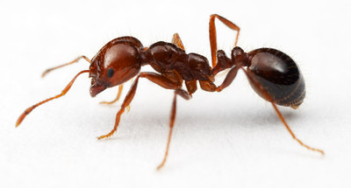
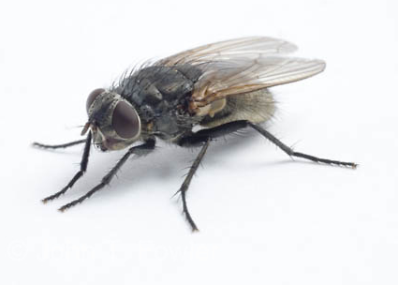
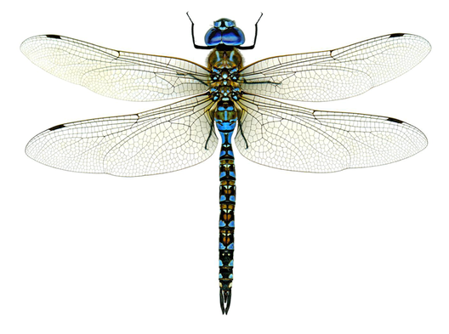
Insects have three body parts:

1_______________ 2_________________ 3_________________

Insects have ___________ legs

Some insects have ______________

Most insects have_______________

Butterflies have four stages in their life
1 Egg, 2____________, 3______________
4 Adult

Some insects are _________, and some are_________
Words to fill in the blanks

Wings Bad Eating Thorax Pupa Six Gardeners Good Abdomen Malaria Head Larva Pollinate Honey Antennae

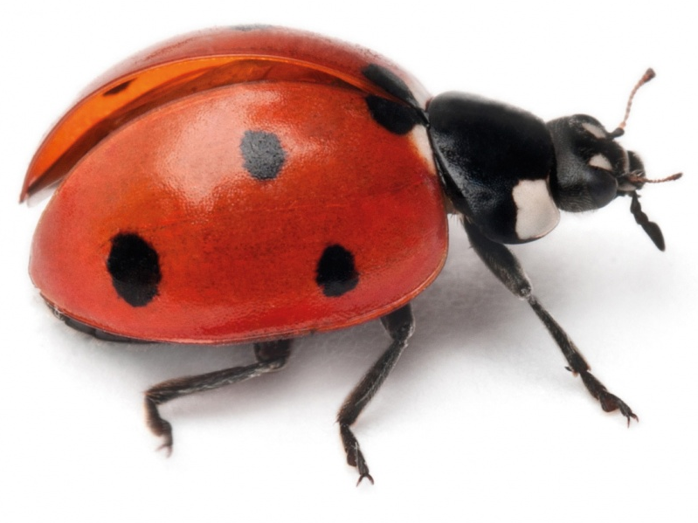

I help ______________ by _____________ aphids
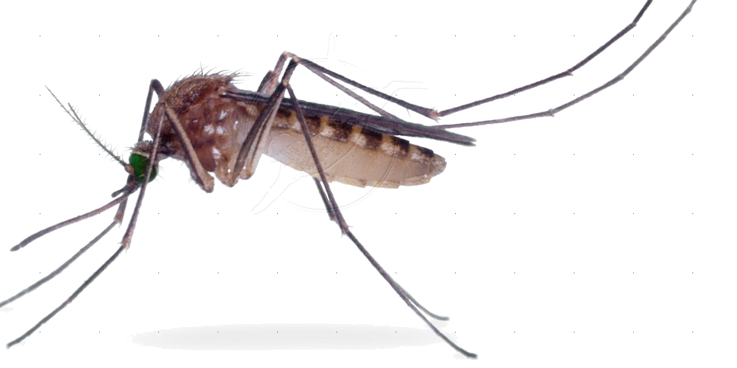

I spread a disease called ______________

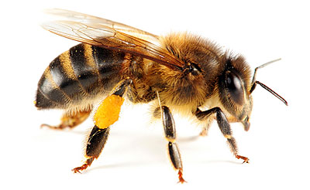

I make ___________ and wax

I also help _________________ flowers

